

A System Dynamics Model of Climate and Malaria Incidence in Colombia

**Un modelo de la dinámica del sistema malaria-clima en Colombia**

**Sebastián Bernal García**

Universidad Nacional de Colombia

Facultad de Minas, Departamento de Ciencias de la Computación y la Decisión

Medellín, Colombia

2017

A System Dynamics Model of Climate and Malaria Incidence in Colombia

**Un modelo de la dinámica del sistema malaria-clima en Colombia**

**Sebastián Bernal García**

Tesis presentada como requisito parcial para optar al título de:

**Magister en Ingeniería – Ingeniería de Sistemas**

Director:

Ph.D. Santiago Arango Aramburo

Codirector:

Ph.D. Germán Poveda Jaramillo

Línea de Investigación:

Dinámica de Sistemas

Grupo de Investigación:

Grupo de Investigación en Ciencias de la Decisión

Universidad Nacional de Colombia

Facultad de Minas, Departamento de Ciencias de la Computación y la Decisión

Medellín, Colombia

2017

*Para todos aquellos cuyo sistema inmune ha conocido la malaria.*

*For all those whose immune system has known malaria.*

**Ackowledgments**

To my parents, this is yours.

To the Universidad Nacional de Colombia, that provided the financial support to this investigation through the grants: Convocatoria DIME 2012-financiación de proyectos de investigación. Modalidad 2 (202010011031); and Convocatoria del programa nacional de proyectos para el fortalecimiento de la investigación, la creación y la innovación en posgrados de la Universidad Nacional de Colombia 2013-2015. Modalidad 2 (200000012989).

To Luisa Díez and Santiago Arango from the Grupo de Investigación en Ciencias de la Decisión; Juan Suaza Vasco and Sandra Uribe Soto from the Grupo de Investigación en Sistemática Molecular; and Germán Poveda Jaramillo from the Posgrado en Aprovechamiento de Recursos Hidráulicos, of the Universidad Nacional de Colombia, sede Medellín, with whom this work has been developed.

To the people of Nuquí for sharing their paradise with me. Andrés, Don Diego, Damaris, y Misa.

To Guillermo Rúa-Uribe of the Universidad de Antioquia, that help me with valuable advice, and provide me extremely valuable data.

To Mercedes Pascual of the Santa Fe Institute, and the University of Chicago, for offer me disinterestedly, her valuable and priceless advice.

To all the organizers, participants of the Workshop on Mathematical Models of Climate Variability, Environmental Change and Infectious Diseases for sharing great moments, and to Colonel Mustard.

To all those who share this pathway with me: Luz Adriana Mora Luna, Juliana Marcela Valencia Leguizamon, Pablo Esteban Londoño, Juan David Suaza, Jessica Arias Gaviria, Martin Rojas, Conor Meehan, Pamela Martinez, y Victoria Romeo Aznar.

Special thanks to Santiago Arango Aramburo for his friendship, mentorship, support, understanding, and patience along all this process.

Abstract

Nowadays, approximately 30% of the Colombians live in endemic lowlands at risk of getting infected with malaria. Nonetheless, it has been shown that climate change has caused, and is expected to continue to cause, the emergence of malaria in non-endemic highlands, where around 70% of Colombians live. Furthermore, strong malaria outbreaks in all Colombia where triggered by the occurrence of El Niño in the last 50 years. For this reason, the aim of this thesis is to develop a model capable of explain the role that climate plays on the vector-host transmission dynamics of malaria in Colombia. To this end, a mathematical system dynamics model that simulates the transmission of *P. falciparum* in an endemic zone forced by air temperature, is developed. Iterated filtering, a recently developed parameter estimation technique, was used to define the unknown value of some parameters of the model, with the purpose of perform numerical simulations of the *P. falciparum* cases. The simulations performed with the Euler method, and an integration interval of one day, found that air temperature was responsible of the malaria outbreaks that occurred in **Nuquí, Choco, in 1997, 1998, 2002 and 2003, during the warm phase of El Niño Southern Oscillation (ENSO), El Niño. This confirms similar findings of previous models developed and simulated in Colombia, and are consistent with the role that climate variability have in the origin of interannual dynamics of malaria in other parts of the world.**

**Keywords: *Plasmodium falciparum* malaria; system dynamics; mathematical model; climate change; El Niño; temperature; Colombia****.**

Resumen

Actualmente, aproximadamente el 30% de los colombianos vive en regiones endémicas de baja altitud, en riesgo de ser infectados con malaria. No obstante, ya se ha mostrado que el cambio climático ha causado, y se espera siga causando la aparición de la malaria en zonas epidémicas de mayor altitud, dónde cerca del 70% de los colombianos vive. Aún más, fuertes brotes epidémicos de malaria en toda Colombia han sido desencadenados por la ocurrencia del fenómeno de El Niño durante los últimos 50 años. Por esta razón, el objetivo de esta tesis, es construir un modelo que sea capaz de explicar el rol que juega el clima en la dinámica de transmisión vector-hospedero de la malaria en Colombia. Para esto, se desarrolla un modelo matemático en dinámica de sistemas que simula la transmisión de *P. falciparum* en una zona endémica, bajo el efecto de la temperatura del aire. Una técnica de estimación de parámetros desarrollada recientemente fue usada para determinar el valor desconocido de algunos parámetros del modelo, con el fin de realizar simulaciones numéricas de los casos de *P. falciparum*. Las simulaciones realizadas con un método de Euler y un tiempo de integración de un día, permitieron encontrar que la temperatura del aire fue la responsable de los brotes epidémicos de malaria que ocurrieron en Nuquí, Chocó en los años 1997,1998, 2002 y 2003 durante la fase cálida de El Niño Oscilación del Sur (ENOS), El Niño. Esto confirma hallazgos similares de modelos desarrollados y simulados previamente en Colombia, y son consistentes con el papel que tiene la variabilidad del clima en dar origen a dinámicas inter-anuales en la malaria en otras partes del mundo.

**Palabras clave: malaria *Plasmodium falciparum*; dinámica de sistemas; modelo matemático; cambio climático; El Niño; temperatura; Colombia.**

**Content**

Pág.

Abstract IX

Resumen X

Figures List XIII

Tables List XV

1. Introduction 1

1.1 Problem Statement 1

1.2 Objectives 1

1.2.1 General 1

1.2.2 Specific 1

2. Background 1

2.1 Type of Models 1

2.2 The Ross-Macdonald Theory of Mosquito-Borne Pathogen Transmission 1

2.3 Malaria Models that Consider Climate 1

3. Methodology 1

3.1 Problem Articulation 1

3.2 Dynamic Hypothesis 1

3.3 Model Formulation 1

3.4 Validation 1

3.4.1 Model Structure 1

3.4.2 Model Behavior 1

4. The System Dynamics Model of Climate and Malaria Incidence in Colombia 1

4.1 Problem Articulation 1

4.1.1 Climate 1

4.1.2 Malaria Burden 1

4.1.3 Entomological Aspects 1

4.1.4 Data Analysis 1

4.2 Dynamic Hypothesis 1

4.3 Model Formulation 1

4.4 Validation 1

4.4.1 Model Structure 1

4.4.2 Model Behavior 1

5. Conclusions and recommendations 1

5.1 Conclusions 1

5.2 Recommendations 1

A. Annex: Temperature Dynamics, and Survival of An. Albimanus Immatures, in a Natural Breeding Site of Colombia 1

1. Temperature Dynamics in a natural breeding site 1

2. Survival of *An. albimanus* immatures in a natural breeding site 1

B. Annex: The non-linear effect of temperature on the life history traits of An. albimanus 1

1. Temperature Dynamics in the Laboratory 1

2. Blood Meal Digestion Rate, Oviposition Percentage and Survival Rate of *An. albimanus* females 1

2.1 Blood Meal Digestion Rate (BMDR) 1

2.2 Oviposition Percentage (OP) 1

2.3 Female Survival Rate (FSR) 1

3. The Development Rate and Survival Percentage of *An. albimanus* immatures 1

3.1 The Development Rate 1

3.1.1 Larvae 1

3.1.2 Pupae 1

3.2 Survival Percentage 1

C. Annex: An explicit vector model 1

Bibliography 1

Figures List

Pág.

*Figure 1.* The Annual Malaria Index (AMI) or Annual Parasitic Index (API) of malaria in Colombia 1959-2014. 1

*Figure 2.* Types of models used to study malaria (1/2). 1

*Figure 3*. Types of models used to study malaria (2/2). 1

*Figure 4.* Diagram of the SIR model 1

*Figure 5.* Structure of the Ross-Macdonald model of malaria transmission 1

*Figure 6.* Temporal tendency of the non-theoretical models published until 2015, which has as its main objective to evaluate the effect of climate variability, in the vector-host malaria dynamics at the population-level, and therefore, in observed malaria incidence. 1

*Figure 7.* Stock and Flow Diagram example. 1

*Figure 8.* Mean Monthly Air Temperature at Nuquí, from January of 1994 to December of 2005. 1

*Figure 9.* Total Monthly Precipitation at Nuquí, from January of 1994 to December of 2005. 1

*Figure 10.* Total monthly *P. falciparum* cases at Nuquí from January of 1994 to April of 2005. 1

*Figure 11.* Total number of *An. albimanus* female mosquitoes in Nuquí from March of 1998 to April of 2005. 1

*Figure 12.* Subsystem diagram of the with implicit vectors 1

*Figure 13*. Stock and Flow and Causal Loop Diagrams of the 1

Figure 14. Simulation of the *P. falciparum* cases in Nuquí, Colombia from *September of 1996 to December of 2003* with different integration methods. 1

*Figure 15.* Daily mean air and water temperature for a natural positive breeding site of *An. albimanus* in Nuquí, Chocó, Colombia. 1

*Figure 16.* Age-distribution and survivorship curve for the immatures stages of *An. albimanus* in July of 2015 at Nuquí, Chocó, Colombia. 1

*Figure 17.* Blood Meal Digestion Rate of *An. albimanus* at constant air temperature 1

*Figure 18.* Oviposition Percentage of *An. albimanus* at constant air temperature 1

*Figure 19.* *An. albimanus* female survival rate under constant temperatures. 1

*Figure 20.* Female survival functions of different *Anopheles* species under constant air temperatures. 1

*Figure 21. An. Albimanus* larvae development rates under constant water temperatures. 1

*Figure 22. An. Albimanus* pupae development rates under constant water temperatures. 1

*Figure 23. An. albimanus* immature survival percentages under constant water temperatures. 1

Tables List

Pág.

Table 1. *Lagged cross-correlations between the fixed number of monthly P. falciparum cases and other lagged variables* 1

Table 2. *Parameters of the*  1

Table 3. *Indirect extreme conditions test.* 1

Table 4. *Summary statistics of model outcomes from September of 1996 to December of 2003* *with different integration methods and integration intervals.* 1

Table 5. *Life table for An. albimanus immatures at Nuquí, Chocó, Colombia.* 1

Table 6. *Instar mortalities of An. albimanus immatures at Nuquí, Chocó, Colombia.* 1

Table 7. *Average daily mortality of An. albimanus immatures* 1

Table 8. *Variables* *of the* . 1

Table 9. *Parameters of the* . 1

# Introduction

## **Problem Statement**

**Weather is the result of the coupling between the natural and the anthropogenic variation of climate. Natural variability is highly complex, with a wide range of spatial and temporal scales that emerge from multiple nonlinearities and feedbacks inside the earth system (Poveda, 2004; Poveda et al., 2011). Moreover, nowadays there is a scientific consensus that climate has changed, and is expected to continue to change due to anthropic activities (Cook et al., 2013; Field et al., 2014; Lovejoy, 2014; Powell, n.d.). Some even talk about a new geologic era: the Anthropocene (Crutzen, 2006; Steffen, Crutzen, & McNeill, 2007). This change has been caused by an increasing trend on the rate of Greenhouse Gases emissions to the atmosphere in the last 100 years, which has increased the global temperature with directly consequences for the human race (and all living beings), being the poorest the ones that suffer the worst consequences with respect to: health, human settlements, armed conflicts, infrastructure, economy, and morbidity and mortality due to extreme weather events, to name just a few (Field et al., 2014)**

**Both the natural and man-driven variability of climate, have an impact on health (Kilpatrick & Randolph, 2012; Kjellstrom & McMichael, 2013; McMichael & Lindgren, 2011; McMichael, Woodruff, & Hales, 2006; Patz, Campbell-Lendrum, Holloway, & Foley, 2005). In general terms, climate change increases the risk or a preexisting problem in the health of a population (Kjellstrom & McMichael, 2013), for example (Boulanger et al., 2014; K. R. Smith et al., 2014; World Health Organization, 2012):**

* **Deaths related to cold, heat, air contamination, floods, fires, and storms.**
* **Mental stress due to heat.**
* **Skin cancer, arteriosclerosis, diarrhea, diabetes, otitis and malnutrition.**
* **Cardiovascular, neurological, renal, ocular, mycotic and mental diseases.**
* **Respiratory diseases: asthma, rhinitis, and respiratory allergies.**
* **Diseases transmitted through:**
  + **Water-Borne Diseases (WBD): Cholera, enteric diseases, and Rotavirus.**
  + **Food-Borne Diseases (FBD): Campylobacteriosis, Salmonellosis, Fascioliasis, enteric diseases, and Rotavirus.**
  + **Vector-Borne Diseases (VBD): hemorrhagic fever with renal syndrome, Onchocerciasis or “river blindness”, Bartonellosis, Schistosomiasis, Rift Valley Fever, Japanese Encephalitis, thick-borne encephalitis, Lyme Disease, Bubonic Plague, visceral and cutaneous Leishmaniosis, Chagas, Leptospirosis, Chikungunya, Yellow Fever, Hemorrhagic Dengue, Dengue and Malaria.**

Malaria is a human parasitic disease caused by five species of protozoans of the *Plasmodium* genus (Centers for Disease Control and Prevention, n.d.), and transmitted to humans by an infective bite of near 70 species of female mosquitoes of the *Anopheles* genus (Sinka et al., 2012). In 2010 almost half of the world population lived at risk of contracting malaria, and 219 million cases and 660,000 deaths were estimated to occur world-wide (World Health Organization, 2013). In the American continent, one species of the *Plasmodium* parasite was introduced through the transatlantic slave trade (Yalcindag et al., 2012), and nowadays 30% of the population of 21 endemic countries live at risk and 8% at high risk of acquire malaria (World Health Organization, 2013). In 2011, 490,000 malaria cases were confirmed microscopically in the Americas (World Health Organization, 2013), of which about 20% take place in Colombia (Padilla, Álvarez, Montoya, Chaparro, & Herrera, 2011).

In Colombia malaria is one of the major public health problems of the nation with approximately 11 million people at risk of get the disease, and two million people living in rural areas with high levels of transmission intensity (Padilla et al., 2011). On those regions almost half of the population is multidimensional and monetarily poor (Departamento Administrativo Nacional de Estadistica (DANE), 2012), and malaria incidence impose a socio-economic burden “on fertility, population growth, saving, investment, worker productivity, absenteeism, premature mortality and medical costs” (Sachs & Malaney, 2002, p. 680).

**Additionally, in Colombia malaria has shown: A clear-cut increasing trend of the AMI or API (the ratio between the total number of cases and the total population at risk per 1000 inhabitants) at a national scale from 1959 to 2010, as shown in Figure 1 (Bouma et al., 1997; Mantilla, Oliveros, & Barnston, 2009; Poveda et al., 2000, 2001, 2011, Poveda & Rojas, 1996, 1997); Epidemic outbreaks at national, regional, and municipal scales, during the occurrence of the warm phase (El Niño) of El Niño/Southern Oscillation (ENSO), over the tropical Pacific from 1959 to 2010 (Bouma et al., 1997; Mantilla et al., 2009; Poveda et al., 2000, 2001, 2011, Poveda & Rojas, 1996, 1997); A clear-cut annual cycle of malaria cases at a municipal level from 1980 to 1997 associated with the hydroclimatic annual cycle (Poveda et al., 2001, 2011); A strong coupling and phase-looking between the annual and interannual (ENSO) variability of climate and malaria cases at a municipal level from 1980 to 1997 (Poveda et al., 2000, 2001, 2011); and extension of the spatial distribution of cases at a regional scale to zones at higher altitudes, due to an increase of air temperature across years between 1990 and 2005 (Siraj et al., 2014). Furthermore it is expected that climate change will cause the emergence of diseases like malaria in non-endemic areas (high confidence), such as the Colombian Andes (Boulanger et al., 2014; K. R. Smith et al., 2014), where around 70% of the Colombian population lives (Padilla et al., 2011).**

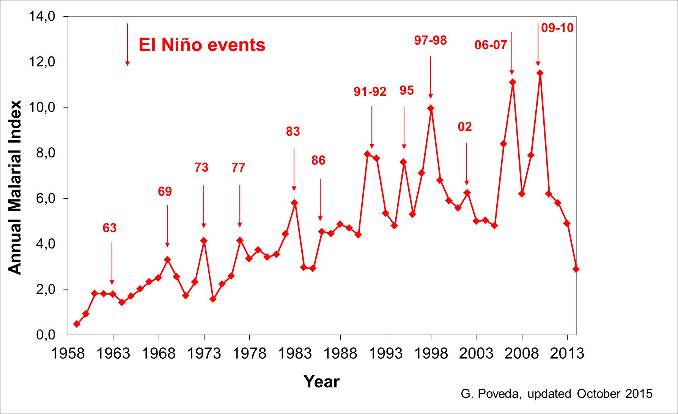

*Figure 1.* The Annual Malaria Index (AMI) or Annual Parasitic Index (API) of malaria in Colombia 1959-2014.

Provided by G. Poveda, personal communication, October 28, 2016.

**These strong and complex relationships between malaria incidence and climate require the development of tools to support decision-making in order to prevent and control the disease (P. Martens & Thomas, 2005; Parham, Christiansen-Jucht, Pople, & Michael, 2011). Such tools are normally mathematical models, that when take into account climate variability allows to: (1) increase the understanding of the complex transmission dynamics under the influence of climate (Parham, Christiansen-Jucht, Pople, & Michael, 2011), and therefore (2) asses different strategies to prevent and control the disease under different climate scenarios (Baeza, Bouma, Dhiman, & Pascual, 2014).**

**For this reason an explanatory mathematical model of the malaria-climate interactions in Colombia was developed (Ruiz, 2002; Ruiz et al., 2002, 2003, 2006). Which was the first published non-theoretical model that aimed to understand the observed relationships of climate and malaria cases. Nonetheless, poor documentation and dimensional inconsistency were found on it. The poor documentation derived in a lack of reproducibility, that is also present in a variety of disciplines, as in the system dynamics computer simulation models (Rahmandad & Sterman, 2012). While the dimensional inadequacy is also present in the biological sciences, and in key concepts of the vector-borne infections theory like the Ross’ threshold theorem, the Macdonald’s basic reproduction "rate", the Garret-Jones’ vectorial capacity, and the Dietz-Molineaux-Thomas’ force of infection, due to an incomplete notation (Eduardo Massad & Coutinho, 2012).**

**Therefore, following the evolutionary nature of science, the mosquito population module of the Ruiz et al. model was improved, using a more detailed, physically-based and properly referenced representation of diverse processes involved in the transmission of malaria (Bernal-García et al., 2014). But despite the progress made, there is still a need to improve some important aspects of the temporal dynamics of the vector-host malaria transmission in Colombia (Bernal-García et al., 2015). This need of improvement is also present in other mathematical models of malaria (D. L. Smith et al., 2014) that include the effect of climate (Parham et al., 2011), to allow them to answer better to strategic questions for malaria elimination (The malERA Consultative Group on Modeling, 2011).**

**There are three main things that put the Bernal-García et al. model (Bernal-García et al., 2014). out of the tool-box for malaria control and prevention in endemic zones of Colombia (Bernal-García et al., 2015): 1) The human population module is still characterized by dimensional inconsistency, 2) the human and mosquito population module are not interacting effectively which derives in an unrealistic representation of the infection process, and 3) the mosquito population is growing exponentially. To overcome these shortcomings we propose the next objectives.**

## Objectives

### General

**Develop a system dynamics model of the vector-host interactions of malaria in an endemic zone of Colombia that takes into account the influence of climate.**

### Specific

* **Make a revision of published malaria models.**
* **Formulate physically-based equations that represents the natural infection process of vectors and host with *Plasmodium spp*. in an endemic zone of Colombia.**
* **Formulate a physically-based model that represents the infection states of humans with *Plasmodium spp.* in an endemic zone of Colombia.**
* **Estimate the in situ daily probability of survival of *Anopheles spp.* larvae and pupae.**

# Background

**The aforementioned Ruiz et al. model (Ruiz, 2002; Ruiz et al., 2002, 2003, 2006) was not an isolated event in the history of the mathematical modelling of climate-driven infectious diseases; but rather, a result of the evolution of mathematical models of mosquito-borne diseases. This chapter deals with the theoretical type of models that one could use to study climate-driven malaria, and the history that led to the development of models as the Ruiz et al. model, and which it aims to develop in this thesis.**

## **Type of Models**

**For malaria one can find mainly two kinds of models: statistical and mathematical (**Figure 2**). Statistical, or black-box models, focus on the aggregate output behavior rather than the causal underlying mechanisms that produce such behavior (Barlas, 1996). Mathematical or white-box models, are statements of how the real system operate and focus on the internal structure of the model (Barlas, 1996). Mathematical models could be classified as dynamic or static (**Figure 2**). The former add the time dimension into the complexity, which allows to “study the evolution of a system over time” and “the inclusion of those aspects of the physical system that are interdependent” (Chitnis, Schapira, Smith, Smith, et al., 2010, p. 15). In contrast static models help to “study the properties of the system at equilibrium” and “assume that the system has reached a steady state solution that does not change with time” (Chitnis, Schapira, Smith, Smith, et al., 2010, p. 15).**

**Dynamic models can be either population-based or individual-based (**Figure 2**). Population-based models, aggregate individuals treating them as identical, and simulate how the number of individuals change over time in each class. Individual-based models (IBM) differentiate each member of the population considering individual characteristics, and simulate their interactions with “demographic, social, climatic, environmental or epidemiological process over time” (Parham, Christiansen-Jucht, Pople, & Michael, 2011, p. 50). While IBM could be closely related to reality, they are also more difficult to analyze or fit to data, requiring substantial computing resources (Chitnis, Schapira, Smith, Smith, et al., 2010; Parham et al., 2011; Railsback & Grimm, 2011).**

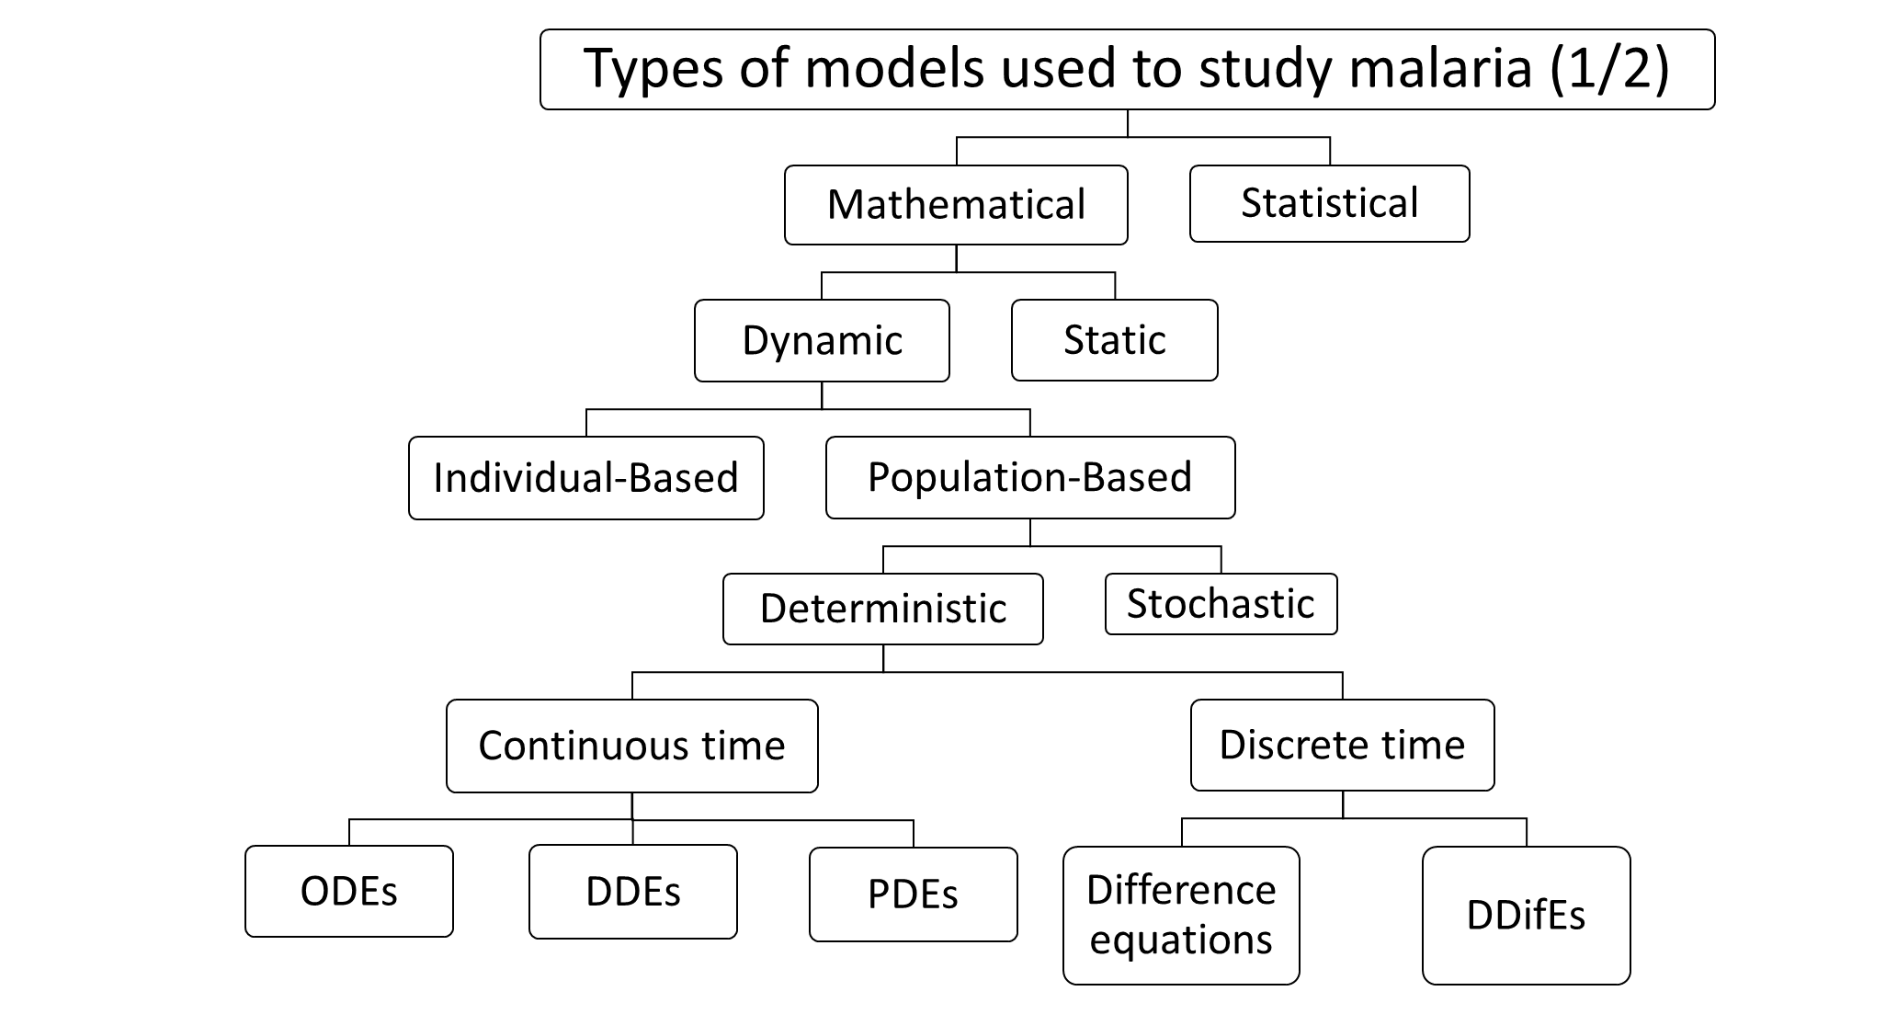

*Figure 2.* Types of models used to study malaria (1/2).

Own elaboration based on Chitnis, Schapira, Smith, Smith, et al. (2010), and Parham et al. (2011).

**Population-based models could be classified as deterministic or stochastic (**Figure 2**). Deterministic models assume the system follow fixed and defined rules with no random variations or noise, where uncertainty is considered via sensitivity analysis. Stochastics models on the contrary, assume randomness or noise within the model formulation, where complex factors that are not understood and cannot be represented, are treated as random noise. Deterministic models assume the randomness has a negligible effect and consider only the average or mean behavior of the system (Chitnis, Schapira, Smith, Smith, et al., 2010; Parham et al., 2011).**

**Although not shown in** Figure 2**, both stochastic and deterministic models could consider time as discrete or continuous. With continuous, times “evolves smoothly over an interval so model parameters reflect the rate at which events occur” (Parham, Christiansen-Jucht, Pople, & Michael, 2011, p. 50). With discrete time, the “values of state variables are only tracked at certain time points of fixed separation” (Parham et al., 2011, p. 50). Continuous time models are described by Ordinary Differential Equations (ODEs), Delay-Differential Equations (DDEs), or Partial Differential Equations (PDEs); and discrete time by difference, or Delay-Difference Equations (DDifEs) (Chitnis, Schapira, Smith, Smith, et al., 2010; Parham et al., 2011). In addition to the distinctions made on** Figure 2**, there is also a distinction between the within-host models that focus on the interactions of the parasite with the immune cells of an individual host, and the vector-host models that focus on the vector-host transmission dynamics. Those vector-host models could consider the vectors explicitly, or implicitly (Figure 3).**

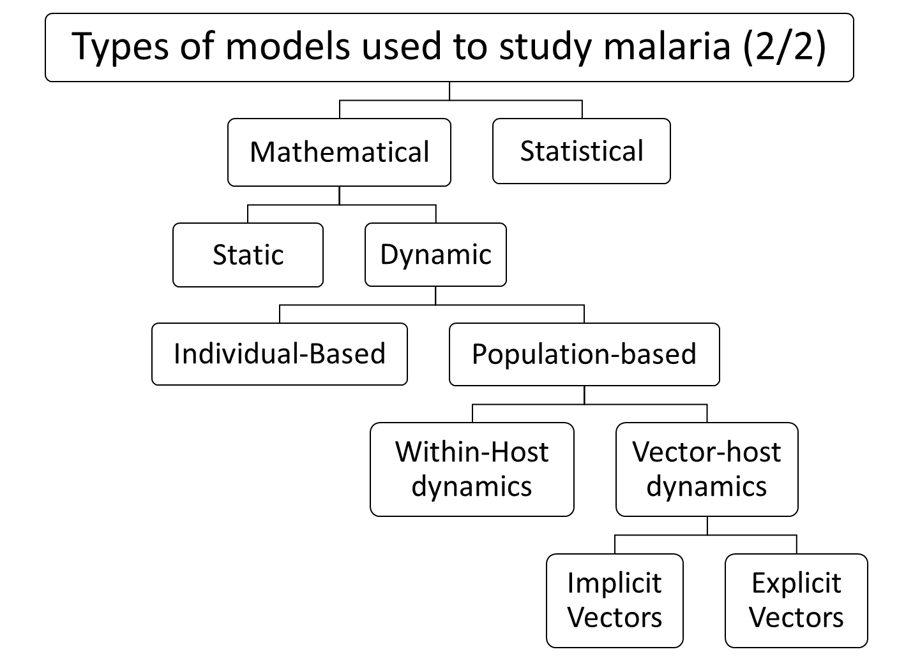

*Figure 3*. Types of models used to study malaria (2/2).

Own elaboration based on Bhadra et al. (2011), Chitnis, Schapira, Smith, Smith, et al. (2010), Laneri et al. (2010), Mandal et al. (2011), and Parham et al. (2011).

## The Ross-Macdonald Theory of Mosquito-Borne Pathogen Transmission

**The first mathematical models of the transmission dynamics of diseases were: the dynamical model for the transmission and control of smallpox developed by Daniel Bernoulli in 1766, the study of En´Ko in 1889 about the transmission dynamics of diseases, and the model of measles transmission of Hamer in 1906 (Brauer & Castillo-Chavez, 2011; Foppa, 2017). Thereafter, Sir Ronald Ross greatly contributed to set the bases of the quantitative theory of malaria, the mosquito-borne diseases, and the epidemiology with the publication of two models of the malaria transmission dynamics in 1908 (Ross, 1908), and 1911 (Ross, 1911) (D. L. Smith et al., 2012). After him Lotka & Sharpe improved in 1923 the second Ross model (Lotka, 1923; Lotka & Sharpe, 1923), including the latency period of the parasite in the mosquito and the host (D. L. Smith et al., 2012). Four years later, Kermack & McKendrick (1927) acknowledged the contributions of Ross to their seminal paper from which the SIR epidemiological compartments modelling approach arose (D. L. Smith et al., 2012).**

**In the SIR model humans are classified in three different classes: Susceptible (S), those who have not been exposed to the pathogen, Infected (I), currently colonized by the pathogen, and Recovered (R), who have successfully cleared the infection (Figure 4). The per-capita rate at which humans in S move to I, and those in I move to R, are represented by the β and γ respectively. The latter is known as the recovery rate, and the former as a composite term of the contact rates and the transmission probability (Keeling & Rohani, 2008).**

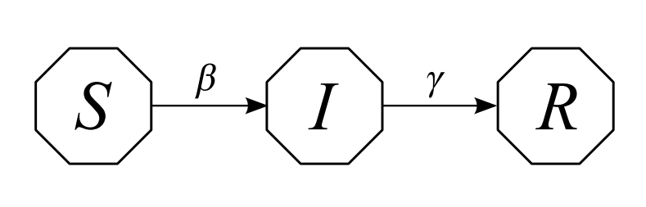

*Figure 4.* Diagram of the SIR model

*Reprinted from* Modelos de la Propagación de Enfermedades Infecciosas *(p. 12),* *by F. Brauer et al., 2014, Cali: Universidad Autónoma de Occidente. Copyright 2014 by Universidad Autónoma de Occidente.*

**Some decades after, the seminal work by Ross was resumed by George Macdonald (Macdonald, 1950, 1952a, 1952b, 1957) introducing: the super infection and the re-infection of those already infected; the adult female mosquito survival; and the blood-feeding cycle (Mandal et al., 2011; D. L. Smith et al., 2012). Later on Garret-Jones (1964) contributed to the mathematical theory with methods for measure the transmission entomologically in 1964, and Macdonald published the first computer simulation of a mosquito-borne pathogen (D. L. Smith et al., 2012). Nevertheless, the most important contributions of Macdonald where: to develop a quantitative theory of control, which Ross was looking for, that helped give quantitative support to the first Global Malaria Eradication Program (GMEP); and synthetize quantitatively the epidemiology and the entomology of malaria (D. L. Smith et al., 2012). The result was the Ross-Macdonald theory of mosquito-borne pathogen transmission (D. L. Smith et al., 2012), from which the Ross-Macdonald model arose.**

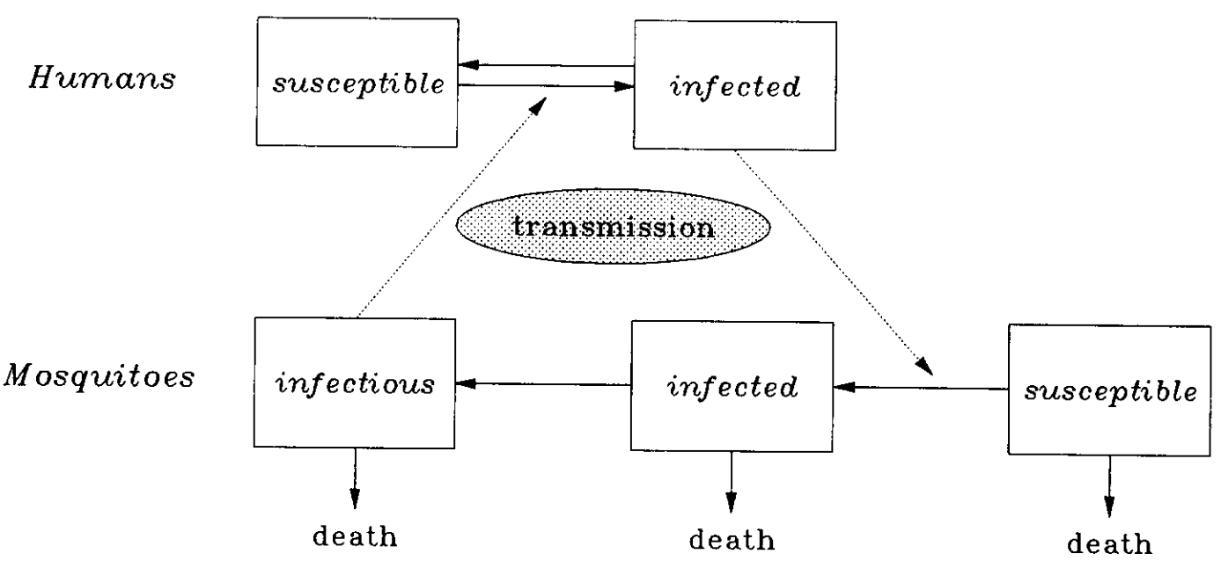

*Figure 5.* Structure of the Ross-Macdonald model of malaria transmission

*Reprinted from* “On the use of mathematical models of malaria transmission,” *by J.C. Koella, 1991, Acta tropica, 49 (1), p.3. Copyright (1991) by the Elsevier Science Publishers B.V.*

**In the Ross-Macdonald model humans are classified as susceptible or infected, while mosquitoes as susceptible, infected, or infectious (Figure 5). Infected mosquitoes have the parasite, but are incapable of transmiting it, while the infectious can transmit the parasite to susceptible humans. Human and mosquito populations are connected through the transmission process marked with dotted arrows in Figure 5. Infectious mosquitoes affect the rate at which humans move from S to I, and the rate at which mosquitoes go from S to I depends on infected humans.**

**From the Ross-Macdonald theory of mosquito-borne pathogen transmission, different models have emerged considering differences on: pathogens, constraints in the measure of the transmission, mosquitoes, immune response, tools and public health problems (Reiner et al., 2013). From 1970 to 2010, 388 biological mathematical models for a pathogen transmitted by a mosquito were published, of which 207 (53%) were published between 2005 and 2010 (Reiner et al., 2013). From that total, 230 were developed for malaria (57%), 77 for dengue (20%), 31 for West Nile Virus (8%), and the remaining 15% for other pathogens associated with Filariasis, Rift Valley fever, yellow fever, Chikingunya, Ross River fever, Japanese encephalitis, Murray Valley encephalitis, and Eastern Equine encephalitis (Reiner et al., 2013). From the 230 published malaria models (Reiner et al., 2013):**

* **15 (6.5%) considered a temperature dependent pathogen development rate in the mosquito (Alonso, Bouma, & Pascual, 2011; Artzy-Randrup, Alonso, & Pascual, 2010; Bomblies, Duchemin, & Eltahir, 2008; Bomblies & Eltahir, 2009; Chitnis, Schapira, Smith, & Steketee, 2010; Chiyaka, Garira, & Dube, 2007; Hoshen & Morse, 2004; Linard, Ponçon, Fontenille, & Lambin, 2009; E. Massad & Forattini, 1998; Okumu, Govella, Moore, Chitnis, & Killeen, 2010; Parham & Michael, 2010a, 2010b; Ruiz et al., 2006; Wyse, Bevilacqua, & Rafikov, 2007; Yang, 2000);**
* **12 (5.2%) considered that the development of immature stages was temperature dependent (Alonso et al., 2011; Bomblies et al., 2008; Bomblies & Eltahir, 2009; Chiyaka et al., 2007; Hoshen & Morse, 2004; Linard et al., 2009; E. Massad & Forattini, 1998; Parham & Michael, 2010a, 2010b; Ruiz et al., 2006; Yang, 2000);**
* **11 (4.8%) adopt a temperature dependent adult mosquito mortality in the absence of control (Alonso et al., 2011; Bomblies et al., 2008; Bomblies & Eltahir, 2009; Hoshen & Morse, 2004; P. Martens et al., 1999; W. J. M. Martens, Jetten, Rotmans, & Niessen, 1995; W. J. M. Martens, Niessen, Rotmans, Jetten, & Mcmichael, 1995; E. Massad & Forattini, 1998; Parham & Michael, 2010a, 2010b; Ruiz et al., 2006);**
* **9 (3.9%) undertake that the blood feeding rates vary with temperature in the absence of control (Alonso et al., 2011; Bomblies & Eltahir, 2009; Hoshen & Morse, 2004; P. Martens et al., 1999; W. J. M. Martens, Jetten, et al., 1995; W. J. M. Martens, Niessen, et al., 1995; Parham & Michael, 2010a, 2010b; Ruiz et al., 2006);**
* **7 (3%) assume that the aquatic habitat was created and destroyed by rainfall/desiccation (Alonso et al., 2011; Bomblies et al., 2008; Bomblies & Eltahir, 2009; Gu, Regens, Beier, & Novak, 2006; Hoshen & Morse, 2004; Parham & Michael, 2010a; Ruiz et al., 2006); and**
* **6 (4.3%) considered that temperature affects the development of immature stages, the adult mosquito mortality, the blood feeding rates, and the pathogen development rate in the mosquito (Alonso et al., 2011; Bomblies & Eltahir, 2009; Hoshen & Morse, 2004; Parham & Michael, 2010a, 2010b; Ruiz et al., 2006).**

**However only 5 (2.2%) malaria mathematical models reviewed by Reiner et al. (2013) included the 5 aforementioned climate dependencies (Alonso et al., 2011; Bomblies & Eltahir, 2009; Hoshen & Morse, 2004; Parham & Michael, 2010a; Ruiz et al., 2006). Highlighting the need of more explanatory mathematical models that account for the diverse effects of climate variables in the transmission of malaria.**

## Malaria Models that Consider Climate

**The works by Ross (1911), Macdonald (1957), and Anderson & May (1991), are identified as the pioneer initial basic models, from which many other models have been developed (Mandal et al., 2011). Those new models have advanced in the inclusion of: the parasite latency period in the host; the acquired immunity of the host; the host and the mosquito age; migration and immigration of the host population; spatial heterogeneity; parasite, host and vector genetics; parasite resistance to medicine and vector resistance to insecticides; socioeconomic factors; and climatic and environmental factors (Chitnis, Schapira, Smith, Smith, et al., 2010; Mandal et al., 2011; D. L. Smith et al., 2014; Teboh-Ewungkem, Ngwa, & Ngonghala, 2013).**

**In this section, a review of non-theoretical models, which has a main objective to evaluate the effect of climate variability, in the vector-host malaria dynamics at the population-level, and therefore, in observed malaria incidence, is presented. A total of 14 models met this requirements (Figure 6), from which 6 were developed for Africa** (Alonso, Bouma, & Pascual, 2011; Ermert, Fink, Jones, & Morse, 2011a, 2011b; Hoshen & Morse, 2004; Laneri et al., 2015; Montosi, Manzoni, Porporato, & Montanari, 2012; Tompkins & Ermert, 2013)**, 4 for India** (Baeza, Bouma, Dhiman, & Pascual, 2014; Bhadra et al., 2011; Laneri et al., 2010; Roy, Bouma, Dhiman, & Pascual, 2015; Roy, Bouma, Ionides, Dhiman, & Pascual, 2013)**, 3 for Colombia** (Bernal-García et al., 2014; Ruiz, 2002; Ruiz et al., 2002, 2003, 2006)**, and 1 for Venezuela** (Rodríguez, Delgado, Ramos, Weinberger, & Rangel, 2013)**. Mercedes Pascual and Menno Bouma are the authors that have published more of them, with a total of 6 (43%) models developed together** (Alonso et al., 2011; Baeza et al., 2014; Bhadra et al., 2011; Laneri et al., 2010; Roy et al., 2015, 2013)**.**

**The first vector-host models that take into account the effect of climate on a vector borne-disease were developed in the first half of the 90’s for dengue with dynamic populations (Focks, Daniels, Haile, & Keesling, 1995; Focks, Haile, Daniels, & Mount, 1993a, 1993b). These pioneer studies were followed by a series of static models based on the Epidemic Potential (EP) and the Vectorial Capacity (VC). The EP is the inverse of the critical density threshold of vector populations, needed to maintain parasite transmission proposed by Dietz (1988). This EP was used to analyze the global effects of an anthropogenically induced climate change on the risk of acquire *P. vivax* and *P. falciparum* malaria (Jetten, Martens, & Takken, 1996; W. J. M. Martens, 1997, 1998; W. J. M. Martens, Jetten, & Focks, 1997; W. J. M. Martens, Jetten, Rotmans, & Niessen, 1995; W. J. M. Martens, Niessen, Rotmans, Jetten, & Mcmichael, 1995). The Vectorial Capacity model proposed by Garret-Jones (1964), was used to relate the effect of temperature on the density of *Anopheles spp.* adult females with malaria risk (E. Massad & Forattini, 1998) and examine the ability of an European vector to transmit *P. vivax* malaria (Lindsay & Birley, 1996).**

*Figure 6.* Temporal tendency of the non-theoretical models published until 2015, which has as its main objective to evaluate the effect of climate variability, in the vector-host malaria dynamics at the population-level, and therefore, in observed malaria incidence.

Own elaboration in Microsoft Excel (2012).

**The EP was also used to explore the way in which the global climate change could influence future malaria patterns at a regional level for the African highlands as a whole, and at a local level for Zimbabwe (Lindsay & Martens, 1998). In addition the EP was validated in Colombia with *P. vivax* epidemiological records, where it was able to reproduce the interannual variation in cases, the peaks, and the upward trend with time (Poveda et al., 2000). Later on, the EP was improved and named Transmission Potential (TP), which allows to estimate the potential impact of climate change on global malaria transmission, and the future populations at risk of malaria for the WHO regions (P. Martens et al., 1999).**

**In 1997, the first vector-host mathematical model that accounts for the effect of climate on malaria transmission was developed by Martens (1997) & Janssen (1997). They use an evolutionary modeling approach to simulate the adaptation of *P. falciparum* parasites to drugs, and that of *Anopheles spp*. mosquitoes to the available pesticides, and changes in temperature. This was done by coupling genetic algorithms with a dynamic malaria-epidemiological model. The latter consists of a constant mosquito population represented by the EP that interacts with a dynamic human population. “The transitions between the reservoirs of the human populations at risk were based on a microparasite-epidemiological model as described in Anderson & May (1991), Aron & May (1982), Bailey (1982), and Levin, Hallam, & Gross (1989).” (W. J. M. Martens, 1997, p. 41).**

**Yang (2000) published the first mathematical model of malaria and climate with dynamic populations on ODEs. He developed a “malaria transmission model taking into account different levels of acquired immunity among human hosts and temperature-dependent parameters related to vector mosquitoes” (Yang, 2000, p. 228). This model allowed to analyze “the epidemiological impact of temperature changes and social and economic conditions on malaria incidence in communities with different levels of acquired immunity …” (Yang & Ferreira, 2000, p. 215). However, Yang (2000) and Janssen & Martens (1997) models were merely theoretical, since they weren’t developed for a specific location or validated with epidemiological records.**

**The first non-theoretical model that aimed to understand the observed relationships of climate and malaria cases was developed in Colombia with ODEs. The first simulations of the model were done for *P. falciparum* and validated in Nuquí, Chocó, an endemic site on the Pacific coast of Colombia during El Niño 1997–1998 and La Niña 1998–2000 (Ruiz, 2002; Ruiz et al., 2002, 2003). Then the time horizon for the mentioned study site was extended to December of 2003, and a new endemic area located in the north-west of Colombia, El Bagre, Antioquia, was added (Ruiz et al., 2006). Although the model develop an *An. albimanus* mosquito population module with the purpose of simulate the dynamics of the vector population, malaria incidence simulations were done with constant mosquitoes densities.**

**The Ruiz et al. (2006)** **model was included later in a Multi Model Ensamble (MME) that simulate the *P. falciparum* incidence in: the Kisii District of the province of Nyanza, an African highland; the District of Chobe, in Northern Botswana; and in the same municipalities than before, Nuquí, and El Bagre (Ruiz, Connor, & Thomson, 2008a, 2008b).In addition, as part of the Integrated National Adaptation Pilot Project (INAP) of Colombia, this MME was included as a component of the malaria early warning system of Colombia (Poveda et al., 2008; Ruiz et al., 2006, 2014), and used to simulate *P. falciparum* cases in the municipalities of Montelibano and Puerto Libertador, Cordoba; San José del Guaviare, Guaviare; and Buenaventura, Chocó (Ruiz, 2013; Ruiz et al., 2014).**

**The first non-theoretical malaria model with dynamic populations was developed in the University of Liverpool, U.K. (Hoshen & Morse, 2004). This model allows to simulate *P. falciparum* malaria in the Hwange District, Matabeleland, Zimbabwe with ground station (Hoshen & Morse, 2004), and weather reanalysis data (Hoshen & Morse, 2005). The weather-based dynamic malaria model was formulated with “delay differential equations based on probabilistic transition between groups” (Hoshen & Morse, 2004, p. 3). It incorporates the stages of the malaria vector *An. gambiae* and their dependence on temperature and rainfall. It was also “driven with the output from the DEMETER multi-model seasonal climate predictions, to produce probabilistic hindcasts of malaria prevalence” (Morse, Doblas-Reyes, Hoshen, Hagedorn, & Palmer, 2005, p. 464), and used “to carry out the validation of the DEMETER multimodel reforecasts for seasonal prediction of malaria in Botswana, south Africa” (Jones & Morse, 2010, p. 4202).**

**The Hoshen & Morse (2004) model was improved later in terms of the parameter setting and the mathematical formulation (Ermert, Fink, Jones, & Morse, 2011a). In addition, entomological and epidemiological field data of West Africa was used for parameter calibration and validation, the new model was called the Liverpool Malaria Model (LMM) (Ermert, Fink, Jones, & Morse, 2011b). Since then, the LMM has been used to map malaria risk in West Africa based on climatic indicators (C. Caminade et al., 2011); to evaluate the possible effect of climate change on malaria transmission in Africa (Ermert, Fink, & Paeth, 2013) and all the globe (Cyril Caminade et al., 2014); and perform “a 30-year hindcast of malaria incidence in India with output from a state of the art coupled atmosphere-ocean seasonal forecast model” (Lauderdale et al., 2014, p. 2).**

**Bhadra et al. (2011) and Laneri et al. (2010) developed a different view of mathematical modelling, such that they changed completely the vector-host, population-based mathematical models of climate-driven malaria. In a novel approach, they do not consider explicitly the mosquito populations any longer; and consider simultaneously human immunity, and fluctuations in mosquito densities produced by environmental changes (Bhadra et al., 2011; Laneri et al., 2010). The models are a coupled nonlinear system of stochastic differential equations driven by Lévy noise, and defined as a Partially Observed Markov Process (POMP) (Bhadra et al., 2011). Additionally, they a recently developed parameter estimation technique for POMP models, based on a sequential Monte Carlo method, iterating filtering. This, approach allows to compare different classes of models, considering hypotheses on the origin of the interannual variation of malaria epidemics. Which in their case where, rather the endogenous feedback structure of the epidemiological system or the exogenous climate forcing, were responsible of the epidemics in desert and semi-arid regions of India (Laneri et al., 2010). These studies also provide the “statistical foundations for building and analyzing dynamic models of population-level malaria transmission that can be confronted to time series data” (Bhadra et al., 2011, p. 442).**

**The Bhadra et al. (2011) and Laneri et al. (2010) approach, allows to model *P. vivax* infections under the effect of climate with dynamic populations for the first time, in a low-endemic region in North West India (Roy, Bouma, Ionides, Dhiman, & Pascual, 2013). In this study, they introduced a simple model with a Q class, which accounts for partially immune individuals, and a chain of H classes, to capture the liver dormant stage of *P. vivax*, hypnozoites (Roy et al., 2013). The model results support “the feasibility of regional elimination and lending support to the expressed urgency of replacing Primaquine, the anti-relapse drug now in use for over fifty years with unsatisfactory efficacy, resistance and side-effects.” (Roy et al., 2013, p. 2)**

**Therefater, the Q class was proposed in a model for *P. falciparum* and *P. vivax* infections, where iterated filtering was used to estimate unknown parameters of this models (Roy, Bouma, Dhiman, & Pascual, 2015). These models were used to generate yearly forecast of out-of-fit epidemiological data, to distinguish the roles of climate variability and intervention methods in generating non-stationarities in observed data (Roy et al., 2015). Afterwards Laneri et al. (2015) modeled for the first time endemic malaria making use of iterated filtering and the implicit vector approach, with the aim of disentangle the relationship between climate and immunity. The results “suggests for the first time to our knowledge that clinical immunity to malaria might buffer or even halt the effect of climate on transmission intensity in endemic settings in general” (Laneri et al., 2015, p. 8790) and “open the possibility of forecasting malaria from climate in endemic regions but only after accounting for the interaction between climate and immunity” (Laneri et al., 2015, p. 8786).**

**Another model that has considered malaria transmission between human and mosquito populations, under the effect of climate, was proposed by Alonso, Bouma & Pascual (2011). The model was the first to evaluate “ … the effect of local warming trends with a quantitative approach that explicitly considers the full transmission cycle of malaria.” (Alonso et al., 2011, p. 1661). They use a thirty year time series of confirmed malaria cases in the Kericho district of the Kenyan highlands, to evaluate if an observed increase of 1ºC in those thirty years was responsible for an observed increasing trend in the cases. In this case, they do not use iterating filtering, but genetic algorithms to estimate unknown parameters that maximize the likelihood of simulated and observed cases. The authors conclude that their “ … findings support a significant effect of warmer temperatures on the exacerbation of malaria in this East African highland, while also allowing for a role of other factors.” (Alonso et al., 2011, p. 1662).**

**Montosi, Manzoni, Porporato, & Montanari (2012) proposed that soil water content, in addition to rainfall and temperature, could also play a role as a driver of malaria incidence. To test their hypothesis, they developed an eco-hydrological model that consists of a coupled model of vector-host malaria transmission with a hydrological model describing soil water content. Then, they reduce the full non-linear eco-hydrological model to a minimal, linear, simple model, and use it to describe malaria incidence in three South African provinces. Despite this assumptions they “show that soil water content can account for a significant portion of malaria’s case variability beyond its seasonal patterns, whereas neither temperature nor rainfall alone can do so (Montosi et al., 2012, p. 2759).**

**Tompkins & Ermert (2013) also considers a vector-host dynamical model that takes into account the effect of rainfall and temperature in the mosquito population, and a surface hydrology model. This model is a grid cell distributed dynamical model, called VECTRI (VECtor-borne disease community model of the International Centre for Theoretical Physics, TRIeste), that “can be used on a relative fine spatial resolution of order 10 km but applied over a regional scale” (Tompkins & Ermert, 2013, p. 2). VECTRI simulations of the entomologic inoculation rate and circumsporozoite protein rate, has shown good results compared with field data from a wide variety of endemic and epidemic locations in West Africa. In addition, VECTRI was used along the LMM and other models, to evaluate the possible effect of climate change on global malaria transmission (Cyril Caminade et al., 2014).**

**Rodríguez et al. (2013) proposed a dynamic model for malaria in South America, with four state variables and rainfall as the forcing, to study malaria incidence in some localities of Paria peninsula in Sucre State, Venezuela. Thereafter, they reduced the system of equations to a one-dimensional equation, with 4 delays, and estimate parameters with this resulting equation. The resulting simulations mimic 80% of observed incidence wit 95% of confidence, and reveal that the localities under study exhibit different dynamics.**

**Finally, Baeza et al. (2014), using a coupled human-mosquito model, explore for the first time the effectiveness of different strategies under environmental variability. They considered a reactive policy, and a proposed climate-based policy. The reactive one is the used by public health authorities, and depends on observed malaria incidence in the past, therefore creating a feedback between the current control strategy and past incidence levels. While the climate-based is based on rainfall levels, acting as an external forcing to the system rather than an endogenous variable. The authors focus on the Indoor Residual Spraying (IRS) control strategy in a low transmission and desert region of northwest India, where rainfall plays a major role driving epidemics (Bhadra et al., 2011; Laneri et al., 2010; Roy et al., 2015, 2013). Their results show that reactive policies create cycles in malaria in the absence of environmental variability, and that climate-based control strategies are more efficient and effective.**

# Methodology

**System Dynamics (SD) was developed by professor Jay W. Forrester at the end of the 60’s at the Massachusetts Institute of Technology (MIT), applying the control theory used in electric and electronic engineering, to social and industrial problems (Jay W Forrester, 1989). Professor Forrester also invented a computer random access magnetic core memory, which set the basis for the development of the first digital computers (Dizikes, 2015). Nowadays, SD is an assisted computer modelling approach for theory building; analysis and design of policies; and strategic decision support, applied to dynamic problems in social, managerial, economical or ecological complex systems – literally any dynamic systems characterized by interdependence, mutual interaction, information feedback, and circular causality (Richardson, 2009; System Dynamics Society, n.d.). Therefore, SD allows to manage systems with high levels of dynamical complexity, studying the structures that create the behavior of those systems (Sterman, 2000b).**

**Models are represented through a computer simulation model expressed in a system of coupled, non-linear, first-order differential (or integral) equations (Richardson, 2009). This system have been called a state-determined system, an absolute system, an equifinal system, and a dynamical system (Richardson, 2009). The numerical solution of this system are actually a simulation exercise, and it allows to understand problems and their possible solutions mechanisms, which reduce the economic and social costs that require the essay of policies and strategies in a real system (Jay W Forrester, 1995; Sterman, 2002). Given that the human mind reasoning is limited and linear, SD is a powerful tool that allows to understand more completely the structure of complex systems, and therefore make better decisions (Jay W Forrester, 1995; Sterman, 2002).**

**SD models have been applied to business policy and strategy, public policy, diffusion of innovations, scenario-driven planning, economics, organizational learning, environment, energy, climate change, and other sectors (Meyers, 2011). Applications in the health sector are wide and include: smoking cessation; reduction of alcohol-related harm; cardiovascular disease prevention; screening for cervical cancer; screening for chlamydia; emergency health and social care; forensic mental health bed capacity; pharmacotherapy maintenance system; clinical preventive care; plan for disasters; HIV/AIDS; polio; tobacco control; obesity; treatment and diagnosis of mental health; health management; heart disease; diabetes; drug resistant pneumococcal; heroin addiction; cocaine prevalence; health care capacity and delivery; dental care; interactions between health care or public health capacity and disease epidemiology; dengue fever, chikungunya and malaria (Atkinson et al., 2015; Flessa, 1999; Hirsch & Homer, 2009; Homer & Hirsch, 2006; Luke & Stamatakis, 2012; Mecoli, De Angelis, & Brailsford, 2013; Newman, Martin, Velasco, & Fantini, 2003; Wolstenholme, 2009).**

**Given that malaria incidence under the influence of climate variability is characterized by dynamic complexity, this is, by feedbacks, nonlinearities and delays, system dynamics it’s an appropriate methodology to study it. The reader can found later feedbacks in Figure 13, and delays in Equations 4.8 to 4.10. Although more feedbacks and delays can be found in the malaria transmission system, as shown in Bernal-García et al. (2015), and in Alonso et al. (2011) respectively. With respect to nonlinearities, they are also present in the malaria transmission forced by climate changes, as shown in Annex B. More nonlinearities can also be found elsewhere (Craig, Le Sueur, & Snow, 1999; W. J. M. Martens, Jetten, & Focks, 1997; Mordecai et al., 2013; Parham & Michael, 2010a). Therefore, the author consider system dynamics as a good methodology to deal with the issue under study.**

**SD follows a modelling process that involves the following steps: (1) Problem articulation, (2) Dynamic hypothesis, (3) Model formulation, (4) Validation, and (5) Policy Analysis (Sterman, 2000b). Although this process “… is a feedback process, an iterative cycle, not a linear sequence of steps. Models go through constant iteration, continual questioning, testing, and refinement. …Iteration can occur from any step to any other step (Sterman, 2000b, p. 87). This thesis will focus on the first four steps, which are explained in detail below.**

## **Problem Articulation**

**“The most important step in modeling is problem articulation. Every model is a representation of a system, but for a model to be useful, it must address a specific problem and must simplify rather than attempt to mirror an entire system in detail. The usefulness of models lies in the fact that they simplify reality, creating a representation of it we can comprehend.” (Sterman, 2000b, p. 89)**

**The most useful tools to articulate a problem are reference modes, and time horizon. The reference mode is “literally a set of graphs and other descriptive data showing the development of the problem over time” (Sterman, 2000b, p. 90). In order to develop the reference mode, one must define the time horizon and the most important variables to understand the problem (Sterman, 2000b). In this case climatic, entomologic, and epidemiologic variables were taken into account to develop the reference mode. While the time horizon was set from January of 1994 to December of 2005, because older or newer data wasn’t available.**

## Dynamic Hypothesis

**Once the problem has been identified and characterized, one starts to develop a theory called dynamic hypothesis, to account for the observed behavior (Sterman, 2000b). It is dynamic because it must explain the dynamics of the problem observed in the reference mode, and it is a hypothesis, because it is always provisional, subject to revision or abandonment (Sterman, 2000b). Two of the most important tools to communicate the dynamic hypothesis are: Causal Loop Diagrams (CLD) and Stock and Flow Diagrams (SFD).**

**A CLD denotes the underlying causal structure of a system and are useful for illustrating the feedbacks between it (Sterman, 2000b). Therefore CLDs can be seen as conceptual representations of the dynamic complexity of a system (Sterman, 2000b). CLDs show the balancing (negative) and reinforcing (positive) feedback loops that produce the dynamic behavior of the system, the interaction among the main variables, and important delays denoted by the “equal” sign on arrows (Sterman, 2000b). The sign at the head of each arrow denotes the nature of the relationship as follows: means that , and that .**

**SFDs along with CLDs represent two central concepts of dynamic systems theory (Sterman, 2000b). Stocks are accumulations, they characterize the state of the system, give systems inertia and provide them with memory (Sterman, 2000b). Stocks are also known as states, state variables, levels, compartments or reservoirs (Sterman, 2000b). Stocks are represented by rectangles, inflows by a pipe (arrow) pointing into (adding to) the stock, and outflows by pipes pointing out of (subtracting from) the stock (Figure 7).**



*Figure 7.* Stock and Flow Diagram example.

Own elaboration in Vensim PLE (Ventana Systems Inc., 2013)

## Model Formulation

**Once the dynamic hypothesis has been developed, it must be tested. To do this, one must pass from the conceptual aspect of the diagrams, to a fully specified formal model with equations, parameters and initial conditions (Sterman, 2000b). Since “stocks accumulate or integrate their flows; the net flow into the stock is the rate of change of the stock. Hence the structure represented in Figure 7 above corresponds exactly to the following integral equation” (Sterman, 2000b, p. 194):**

|  |  |
| --- | --- |
|  | (3-1) |

**“Equivalently, the net rate of change of any stock, its derivative, is the inflow less the outflow, defining the differential equation” (Sterman, 2000b, p. 194):**

|  |  |
| --- | --- |
|  | (3-2) |

**In order to estimate unknown parameters, iterated filtering was used, which is a recently developed parameter estimation method based on a sequential Monte Carlo technique (Laneri et al., 2015; Roy, Bouma, Dhiman, & Pascual, 2015; Roy, Bouma, Ionides, Dhiman, & Pascual, 2013).This methodology use a likelihood-based inference to compute maximum likelihood estimates, and have been successfully applied to malaria dynamical models forced by climate (Bhadra et al., 2011; Laneri et al., 2010, 2015, Roy et al., 2015, 2013).**

**This method consists of two loops, with the external loop iterating the internal “filtering” loop. This internal filtering loop selects the best particles based on their likelihood according to the data, where each particle is a simulation with its own set of parameter values. Thereafter, the second loop takes the best particles and give them back to the internal filtering loop that will use them as initial conditions for a new iteration. In this new iteration, the inner loop mutates each particle (with a mutation factor that decays every external loop), creating a new set of particles that will be selected or discarded based on their likelihood.**

## Validation

**Although validation is a process that pervades all phases of model building, this section presents the tests introduced by Schwaninger & Groesser (2009), which are based on those presented by Barlas (1996), Forrester & Senge (1980), and Sterman (2000a).**

### Model Structure

**These tests can be assessed by direct or indirect inspection, and aim to “assess whether or not the logic of the model is attuned to the corresponding structure in the real world” (Schwaninger & Groesser, 2009, p. 772). Direct structure test “qualitatively assess any disparities between the original system structure and the model structure” (Schwaninger & Groesser, 2009, p. 772), while the indirect structure test “assess the validity of the model structure indirectly by examining model-generated outcome behaviors” (Schwaninger & Groesser, 2009, p. 773).**

### Model Behavior

**“Test of model behavior compare simulation outcomes with data from the real system under study” (Schwaninger & Groesser, 2009, p. 774). In order to validate model behavior the model was simulated in Powersim Studio 10 Academic (Powersim software AS, 2017).**

# The System Dynamics Model of Climate and Malaria Incidence in Colombia

**The system dynamics Model of Climate and Malaria Incidence in Colombia, henceforth, , is a mathematical deterministic model, constituted by a set of ordinary nonlinear differential equations. The is a population-based, vector-host dynamic model, built under the system dynamics methodology.**

## Problem Articulation

**We focus our study on the municipality of Nuquí, located in the Chocó department, along the Pacific coast of Colombia. All the data used to derive the results presented here, as well as more graphs and analysis are available in the folder “Bernal-García, Sebastian_MasterThesis/Chapter 4/Data Analysis/” of the Malaria Colombia online Git-Hub repository (Bernal-García, 2017).**

### Climate

**Climate in the Pacific region is characterized by tropical rainforest that varies from hyperhumid (A) to subhumid (B1, B2) according to Thornthwaite’s classification. The maximum and minimum average annual temperatures in the region are 32,2ºC and 20ºC respectively, while the average mean annual temperature is 25ºC. The average monthly multiannual sun light is 287,4 hours per month, and the average cloud cover in all the region remains in values near to 6 oktas (Rangel, Arellano, & Rangel, 2004). Furthermore, the Pacific region water balances shows excess (Rangel et al., 2004), because the region is one of the rainiest places on Earth, with an average annual rainfall over 12,000 mm, and a relative humidity of 82% (Poveda, 2004; Poveda & Mesa, 2000). This is mostly due to the action of the low-level Chocó jet, which is responsible for the transport of large amounts of moisture from the Pacific Ocean inland (Poveda, 2004; Poveda, Jaramillo, & Vallejo, 2014; Poveda & Mesa, 2000).**

**Regarding climate in the municipality of Nuqui, two meteorological stations of the Instituto de Hidrología, Metereología y Estudios Ambientales de Colombia (IDEAM), were used to characterize it. The first one is named Amargal and is located in the municipality of Nuquí (5'34'', 77'30'') at an altitude of 30 m.a.s.l. Available data for this station comes from November 1st of 1997 to April 30th of 2010. The second station, named Panamericana, is located in the municipality of Bahia Solano (6'13'', 77'24'') at an altitude of 4 m.a.s.l. with available date from January 1st of 1963 to date. The climatic records of these stations were used to calculate the mean monthly air temperature (Figure 8), and the total monthly precipitation (Figure 9) in Nuquí from January 1st of 1994 to December 31st of 2005. A full description of how this was made can be found in a free online code at Git-Hub, alongside more graphs and analysis of this climatic series (Bernal-García, 2017).**

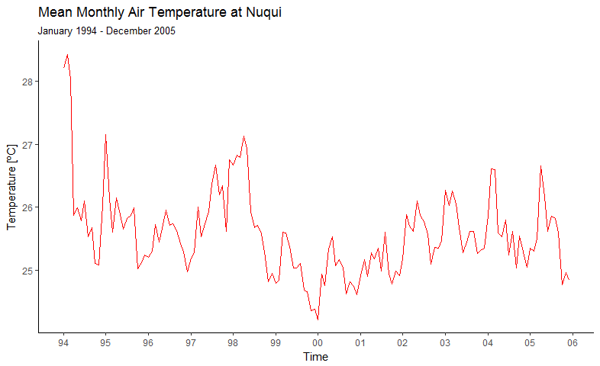

*Figure 8.* Mean Monthly Air Temperature at Nuquí, from January of 1994 to December of 2005.

Own elaboration in R (R Core Team, 2017).

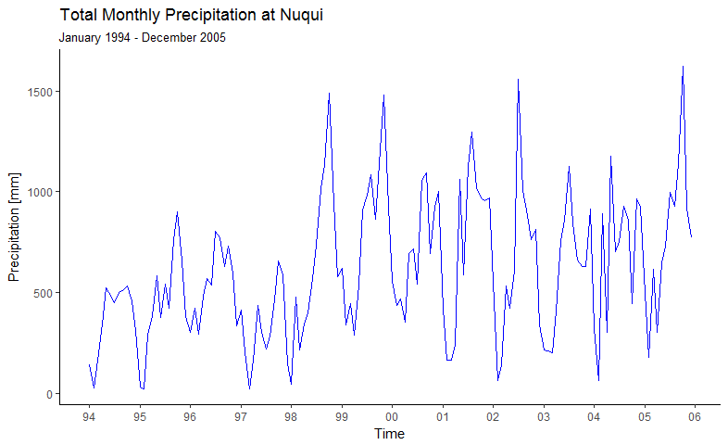

*Figure 9.* Total Monthly Precipitation at Nuquí, from January of 1994 to December of 2005.

Own elaboration in R (R Core Team, 2017).

### Malaria Burden

**The pacific coast is considered the second most important region for malaria transmission in Colombia (Padilla et al., 2011). There, around 5% of Colombia population has accounted for 10% to 30% of the total national malaria cases in the last 50 years (Padilla et al., 2011). There, mining activities, fish farms, illicit crops, internal armed conflicts, subsistence agriculture, and timber industry, contribute to the endemic-epidemic malaria transmission in the region (Padilla et al., 2011). Where most of the inhabitants are Afro descendants, characterized by haemoglobinopathies and Duffy-negative phenotypes, that make them refractory to *P. vivax* infection (Padilla et al., 2011), reason for which we consider in our model only *P. falciparum* infections. The cases reported in Nuquí can be seen in Figure 10, while more graphs and analysis can be found online (Bernal-García, 2017).**

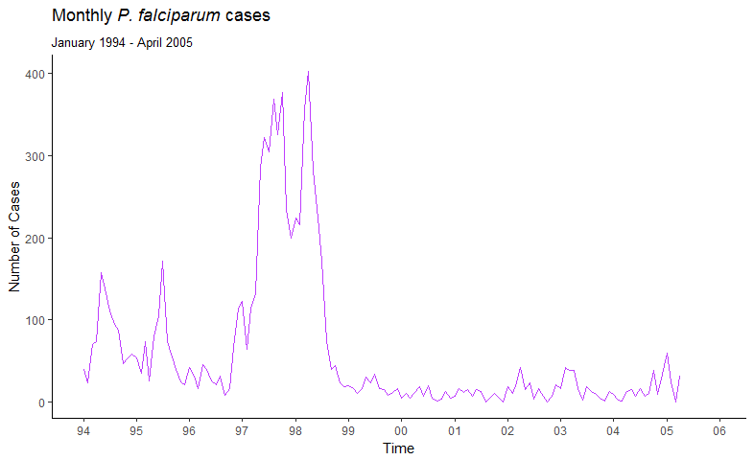

*Figure 10.* Total monthly *P. falciparum* cases at Nuquí from January of 1994 to April of 2005.

Own elaboration in R (R Core Team, 2017). Data were extracted from Ruiz et al. (2006) using WebPlotDigitizer (Rohatgi, 2013).

### Entomological Aspects

**Regarding the presence of *Anopheles* genus mosquitoes in the region, there are records of *An. (Nys.) albimanus* and *An. (Ker.) Neivai* (Carvajal, de Herrera, Quintero, Alzate, & Herrera, 1989; Gutiérrez, Naranjo, et al., 2009; Murillo B., Jaramillo S., Quintero C., & Suarez T., 1989; Naranjo-Diaz, Rosero, Rúa-Uribe, Luckhart, & Correa, 2013; V. Olano, Carrasquilla, & Méndez, 1997; Rúa-Uribe, 2006b), genus that were detected by the research team during their visits to the area. The first species is considered one of the primary malaria vectors in the Americas and Colombia, while the latter has a secondary vector status at both country and continental level. Nonetheless, the role of *An. neivai* at a local and regional range could be primary rather than secondary (Olano, Brochero, Sáenz, Quiñones, & Molina, 2001; Sinka et al., 2010; Montoya-Lerma et al., 2011); however more research is requiered to develop further this hypothesis. For this reason and due to a lack of biologic studies that explore the effect of environmental variability on the life history traits of *An. neivai* we do not consider this vector in our model.**

**The total number of *An. albimanus* females in Nuqui (Figure 11) was calculated with density data extracted from Rúa-Uribe (2006b) using WebPlotDigitizer (Rohatgi, 2013). That density was estimated with monthly sampling using human bait, reason for which its dimensions are mosquitoes/man/hour. In order to obtain the total number of mosquitoes, density was multiplied by the total censed human population (DANE, 2011). The result of this operation was then multiplied by the total number of monthly sampling hours, which were reported to be 12 (3 hours for 4 days each month) (Rúa-Uribe, 2006b).**

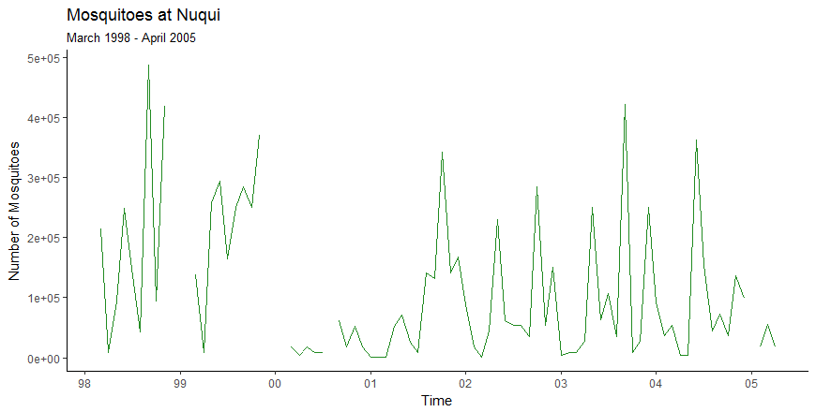

*Figure 11.* Total number of *An. albimanus* female mosquitoes in Nuquí from March of 1998 to April of 2005.

Own elaboration in R (R Core Team, 2017).Data extracted from Rúa-Uribe (2006b) using WebPlotDigitizer (Rohatgi, 2013).

### Data Analysis

**To explore the relationship between the climatic, entomologic and epidemiologic time series in Nuquí during the study period, seasonal plots, scatter plots, boxplots, annual cycles graphs and lagged cross-correlations were analyzed. Here only the lagged Cross-Correlations are presented, while the others as already mentioned, can be found in the folder “Bernal-García, Sebastian_MasterThesis/ Chapter 4/Data Analysis /” of the Malaria Colombia online Git-Hub repository (Bernal-García, 2017). Lagged cross-correlations were computed with the *P. falciparum* cases as the fixed variable, while a lag in months were applied to the others (Table 1).**

**In addition to the climatic series presented before, there are two more relevant climatic variables, the Diurnal Temperature Range (DTR), and the The Oceanic Niño Index (ONI). The former is the most dominant characteristic of climate variability in the tropics (Poveda, 2004), and was computed as the mean of the difference between the maximum temperature, and minimum daily temperature (Bernal-García, 2017). The latter is currently used to define the El Niño Southern Oscillation status (NOAA, n.d.) and was calculated as the 3 month running mean of ERSST.v5 SST anomalies in the Niño 3.4 region (NOAA, 2017).**

Table 1. *Lagged cross-correlations between the fixed number of monthly P. falciparum cases and other lagged variables*

|  |  |  |  |  |  |  |  |  |  |  |  |
| --- | --- | --- | --- | --- | --- | --- | --- | --- | --- | --- | --- |
|  | **Lag in months** | | | | | | | | | | |
|  | **-5** | **-4** | **-3** | **-2** | **-1** | **0** | **1** | **2** | **3** | **4** | **5** |
| **Temperature** | 0.31 | 0.38 | 0.45 | 0.49 | 0.46 | 0.46 | 0.44 | 0.43 | 0.37 | 0.34 | 0.30 |
| **Precipitation** | -0.34 | -0.39 | -0.43 | -0.39 | -0.35 | -0.30 | -0.25 | -0.19 | -0.12 | -0.08 | -0.07 |
| **Mosquitoes** | 0.00 | 0.03 | 0.01 | 0.00 | 0.05 | 0.04 | 0.08 | 0.17 | 0.17 | 0.25 | 0.35 |
| **DTR** | 0.55 | 0.55 | 0.55 | 0.52 | 0.47 | 0.43 | 0.35 | 0.29 | 0.23 | 0.20 | 0.17 |
| **ONI** | 0.46 | 0.50 | 0.54 | 0.56 | 0.57 | 0.55 | 0.52 | 0.46 | 0.40 | 0.34 | 0.27 |

*Note:* Own elaboration with data obtained in R (R Core Team, 2017).

**From Table 1, it is worth it to highlight the small correlation between the number of *An albimanus* female mosquitoes and *P. falciparum* cases; the negative correlation between *P. falciparum* cases and precipitation; and the high positive correlation between *P. falciparum* cases and the air temperature, the DTR and the ONI.**

## Dynamic Hypothesis

**I have constructed a dynamic hypothesis that consider the mosquitoes implicit as done elsewhere (Bhadra et al., 2011; Laneri et al., 2010, 2015, Roy et al., 2015, 2013). This decision is based on the small correlation (Table 1), and weak relationship found between the censed number of mosquitoes and the confirmed *P. falciparum* cases (Rúa-Uribe, 2006b; Ruiz et al., 2006). In addition to some simulation problems of the mosquito population module (Annex C), we were not able to estimate some unknown parameters (**Table 9**) using the same parameter estimation technique mentioned in section 3.3. The implicit vector formulation is “derived from the well-known parameters and treatment of mosquitoes in standard malaria models, rewriting them as non-autonomous with mosquito abundance as the forcing”** **(Laneri et al., 2010, p. 9). Further explanation of this parsimonious representation of the vector can be found in the Text S1, of the online supporting information of Laneri et al. (2010).**

**When considering the vectors implicitly, two subsystems are considered: the human population and the force of infection (Figure 12). This is the key variable, which represents the transmission rate per susceptible (Keeling & Rohani, 2011); additionally, it and can be understood as the force that each susceptible felt to be moved from the class S to the E class. Thus, the mosquito dynamics are modeled implicitly through the force of infection, reason for which climate has an effect on it. The effect of on the human population is not immediate but takes time. The mosquito that acquires the parasite from an infectious human cannot transmit it immediately, but after the completion of the parasite incubation period inside it. However the human effect on the force of infection it is immediate.**



*Figure 12.* Subsystem diagram of the with implicit vectors

Own elaboration in Vensim PLE (Ventana Systems Inc., 2013)

**For the human population the structure proposed by Bhadra et al. (2011) and Laneri et al. (2010) have been considered and named hereafter . The stocks, the most important flows, and parameters of the are shown in Figure 13. Only the death and birth flows, and very few parameters were omitted for cleanness. In addition, the underlying causal structure, composed by feedback loops that explain the observed dynamic behavior of *P. falciparum* cases, can also be seen explicitly in Figure 13. The model considers the following human classes: S1 (susceptible), S2 (partially protected), E (exposed with a latent infection), I1 (infectious and symptomatic), and I2 (asymptomatic with reduced infectivity).**



*Figure 13*. Stock and Flow and Causal Loop Diagrams of the

Own elaboration in Vensim PLE (Ventana Systems Inc., 2013)

**The arrows involved have the same color of the loop identifier. The first (R1), second (R2), and third (R3), feedback loops, involve the transition of humans between the epidemiological compartments, while, the fourth (R4), fifth (R5) and sixth (R6) involve the transmission of the parasite between humans and mosquitoes. Note that all the feedback loops shown are reinforcing or positive, because none first order negative feedback loop is shown for cleanness, although they are present when a stock affects its outflow in a positive way, which is the case of all the outflows of all the stocks of the .**

**A fully susceptible person in S1 that acquires the *Plasmodium* parasite from a mosquito, would enter to E, and after the culmination of the Intrinsic Incubation Period (IIP) would leave E towards I1. This outflow of E, and inflow of I1, is the number of persons reported each month as malaria cases. Consequently, people in I1 are those suffering the clinical symptoms of the disease at time t. A person that clears completely his parasitic load in I1, becomes susceptible again, closing the first positive feedback loop R1: Recovery. In the case there is not recovery, the person becomes an asymptomatic individual with reduced parasitemia in I2. Those asymptomatics that clear they parasitic load after a time, would develop a clinical immunity to the disease (S2), until they lose it, and become susceptible again (Cycle R2: Immunity Loss, Figure 13). An individual that is fully protected from the clinical disease could be reinfected, and could stay moving between the I2 and S2 compartments, in the reinforcing feedback loop R3.**

**In this model, the parasite has three transmission pathways, through the cycles R4, R5 and R6. In the first, it passes from an infectious mosquito () to a fully susceptible human, and stays in E until the culmination of the IIP. Thereafter, the parasite waits in I1 to infect a susceptible mosquito (). Where once inside the stomach of this mosquito, would be ready to infect a susceptible human in after the culmination of the Extrinsic Incubation Period (EIP) or the parasite development rate, (the inverse of the EIP). In the second parasite cycle, R5, the *Plasmodium* takes the same path of R4, but instead of passing directly from I1 to , it passes through I2 before. Finally, the last loop involves the reinfection of a clinical immune human passing from S2 to I2 due to the effect of , and from I2 to . Given the non-linear nature of the air temperature effect on , the variables optimal air temperature, and air temperature difference are shown in Figure 13. This relationship is represented through the mathematical function of (Equation 4-11).**

## Model Formulation

**I this section, we move from the dynamic hypothesis, to a formal model that translates this hypothesis into equations that can be simulated. The general model structure presented in Figure 13 corresponds exactly to the following differential equations:**

|  |  |
| --- | --- |
|  | **(4-1)** |
|  | **(4-2)** |
|  | **(4-3)** |
|  | **(4-4)** |
|  | **(4-5)** |

**The parameter , in the diagram, and , in the equations, are equivalent; it represent the per-capita rate at which an individual in the X class passes to the Y class. The per-capita death rate is derived and averaged from the crude death rate (DANE, n.d.) and the census data (DANE, 2011), which is calculated by the government national statistical agency (DANE) for the simulation period in the study site. The birth rate () into the S class is equal to , and was set to ensure that , where is the population size at time t obtained from interpolated census data from the DANE (2011). The force of infection is:**

|  |  |
| --- | --- |
|  | **(4-6)** |

**where is the fraction of humans population transmitting the parasite to the mosquito vector; and is a number between 0 and 1, that represent the fraction of individuals in that contribute to . The transmission rate is defined as:**

|  |  |
| --- | --- |
|  | **(4-7)** |

**which include the interannual and seasonal effect of a time-varying climate covariate , with coefficient ; and dimensional constant , required to give units of .**

**The delay in the effect of on the infection of human classes and , is also considered. The latent force of infection is delayed into classes (For ) considering gamma-distributed transitions between classes (Lloyd, 2001), up to the current force of infection, , as follows:**

|  |  |
| --- | --- |
|  | **(4-8)** |
|  | **(4-9)** |

|  |  |
| --- | --- |
|  | **(4-10)** |

**Here is the *Plasmodium* development rate, defined by the following non-linear air temperature () dependent function proposed for *P. falciparum* (Paaijmans, Read, & Thomas, 2009):**

|  |  |
| --- | --- |
|  | **(4-11)** |

**Note that in the diagram and in the equations are equivalent. And that although it is represented by a circle in Figure 13, it is a stock, since it is the output of a second order information delay, with average delay time, . However, here this information delay is not modeled with its characteristic of an stock and flow structure, but with the corresponding system dynamics software function counterpart.**

Table 2. *Parameters of the*

|  |  |  |  |  |  |
| --- | --- | --- | --- | --- | --- |
| **Symbol** | **Description** | **Range** | **Value** | **Units** | **References** |
|  | Initial total human population | 6899 | 6899 |  | (DANE, 2011) |
|  | Initial fraction of humans in S1 | (0.8,1) | 0.64 |  | - |
|  | Initial fraction of humans in E | (0,0.1) | 0.00 |  | - |
|  | Initial fraction of humans in I1 | (0,0.1) | 0.03 |  | - |
|  | Initial fraction of humans in I2 | (0,0.1) | 0.32 |  | - |
|  | Initial fraction of humans in S2 | (0,0.1) | 0.00 |  | - |
|  | Initial value of the latent force of infection | (0,1) | 0.01 |  | - |
|  | Per capita transition rate from E to I1 | (14, 61) | 34.28 |  | (Boyd & Kitchen, 1937) |
|  | Per capita transition rate from I1 to S1 | (2, 18) | 3.00 |  | (Filipe, Riley, Drakeley, Sutherland, & Ghani, 2007) |
|  | Per capita transition rate from I1 to I2 | (2, 18) | 13.18 |  | (Filipe et al., 2007) |
|  | Per capita transition rate from I2 to S2 | (0.1, 3) | 0.32 |  | (Ashley & White, 2014; Felger et al., 2012) |
|  | Per capita transition rate from S2 to S1 | (0, 1) | 0.01 |  | (Filipe, Riley, Drakeley, Sutherland, & Ghani, 2007) |
|  | Reporting fraction | (0,1) | 0.99 |  | - |
|  | Relative infectivity of I2 | (0,1) | 0.92 |  | - |
|  | Susceptibility of S2 to infection | (0,1) | 0.08 |  | - |
|  | Climate covariate coefficient | (0,10) | 0.68 |  | - |
|  | Dimensionality constant | 1 | 1 |  | Assumption |
|  | Mortality rate | 0.2 | 0.2 |  | (DANE, n.d., 2011) |
|  | Number of classes | 2 | 2 |  | Assumption |

*Note:* Own elaboration

**Simulated cases are defined as: , where the parameter () is the reporting fraction. This fraction takes into account the reported or detected cases, where some unreported are left out. Table 2, presents all the parameters with the symbol used for its representation; a brief description; the ranges used for estimations, in case it was estimated; the value estimated or used; and the reference for the value or the range. This parameter estimation was implemented in R (R Core Team, 2017) using the MIF2 function of the POMP package (King et al., 2017; King, Nguyen, & Ionides, 2016), using as a guide a R script kindly provided by Mercedes Pascual.**

## Validation

**In this section, the validation process is performed considering the good practices in the literature (Barlas, 1996; Jay Wright Forrester & Senge, 1980; Sterman, 2000a). Thus, we will provide firth the validation of the model structure, and then the model behavior.**

### Model Structure

**To evaluate the structure, direct and indirect test were performed. Direct structure test involve structure examination test, parameter examination test, direct extreme condition test, boundary adequacy structure test, and dimensional consistency test. The model presented here passed the structure examination test, there is not contradiction neither the expert knowledge nor the theoretical knowledge about the structure of the real system. There was an external verification and validation by Dr. Mercedes Pascual, a malaria expert that validated the structure of the model; additionally the structure was also checked with the current state of the art literature on mathematical modelling of climate-forced malaria. In respect to the parameter examination, all the parameters of the model match elements of the real system, with exception of the dimensionality constant , and the numerical values estimated match observed quantities.**

**Moreover, extreme-condition tests was done to the model equations as a mental process, and it passed properly. Regarding boundary adequacy, the model contains the relevant structure relationships to satisfy the model purpose, and the level of aggregation is appropriate. Finally the dimensionality consistency is present in all the equations and therefore in the model, although it was necessary the use of the dimensionality constant .**

**Indirect structure test include indirect extreme condition test, and integration error test. For the indirect extreme condition test, extreme values were assigned to some parameters (**Table 3**).**

Table 3. *Indirect extreme conditions test.*

|  |  |  |  |  |
| --- | --- | --- | --- | --- |
| **Parameter** | **Value assigned** | **Expected Behavior** | **Generated Behavior** | **Satisfy? (Yes/No)** |
|  | 0 | Nothing Happens | Nothing Happens | Yes |
|  | 0 | Zero cases | Zero cases | Yes |
|  | 0 | Zero cases | Zero cases | Yes |
|  | 0 | No transmission | No transmission | Yes |
|  | 14ºC & 36ºC | No transmission | No transmission | Yes |

*Note:* Own elaboration

This test, in particular the values assigned to and **,** help to correct some inconsistencies of the model. In the case of the **birth rate () was redefined as:**

|  |  |
| --- | --- |
|  | **(4-12)** |

**In the case of air temperature (), the values were assigned because below** 14ºC, and above 36ºC, the parasite cannot develop inside the mosquito, and thus one could expect no transmission. However the model enter into an error with these values and was not capable of simulate, given the undefined formulae. Therefore the first term of equation 4.2 was redefined as:

|  |  |
| --- | --- |
|  | **(4-13)** |

and the second term of equation 4.5 as:

|  |  |
| --- | --- |
|  | **(4-13)** |

**Then, the generated model behavior with these values were compared to the expected behavior of the real system under the same extreme conditions present the results of this comparison in the column “Satisfy? (Yes/No)”.**

Table 3. *Indirect extreme conditions test.*

|  |  |  |  |  |
| --- | --- | --- | --- | --- |
| **Parameter** | **Value assigned** | **Expected Behavior** | **Generated Behavior** | **Satisfy? (Yes/No)** |
|  | 0 | Nothing Happens | Nothing Happens | Yes |
|  | 0 | Zero cases | Zero cases | Yes |
|  | 0 | Zero cases | Zero cases | Yes |
|  | 0 | No transmission | No transmission | Yes |
|  | 14ºC & 36ºC | No transmission | No transmission | Yes |

*Note:* Own elaboration

This test, in particular the values assigned to and **,** help to correct some inconsistencies of the model. In the case of the **birth rate () was redefined as:**

|  |  |
| --- | --- |
|  | **(4-12)** |

**In the case of air temperature (), the values were assigned because below** 14ºC, and above 36ºC, the parasite cannot develop inside the mosquito, and thus one could expect no transmission. However the model enter into an error with these values and was not capable of simulate, given the undefined formulae. Therefore the first term of equation 4.2 was redefined as:

|  |  |
| --- | --- |
|  | **(4-13)** |

and the second term of equation 4.5 as:

|  |  |
| --- | --- |
|  | **(4-13)** |

**The results of the integration error test are presented in** Table 4 **and** Figure 14**. In general, the model exhibits no sensitivity to the integration method, nor to the simulation time step, or integration interval (). The only combination that generates substantially different outcomes was Euler with a time step of one month, where the model would then be considered as a discrete model instead a continuous one.**

### Model Behavior

The simulation period was set from September of 1996 to December of 2003, with air temperature with no lag as the climate covariate **().** The reason of this decision is that during all this 7 years and 4 months, reported *P. falciparum* cases in Nuquí are very tight to temperature dynamics, with only two months on 2001 with zero reported cases **(Bernal-García, 2017).** A reason for that could be an administrative unreported rather than the absence of cases. **Air temperature was standardized to make of a dimensionless quantity. This standardization was done by subtracting to each month measure, the mean, and dividing this difference by the standard deviation.**

In order to asses the model capability to reproduce the observed behavior of the real system “there is ultimately no substitute for plotting the simulated and actual data together” (Sterman, 2000b, pp. 874–875) which is shown in Figure 14**. Nonetheless** different statistics were also used to analyze the point-by-point fit, and to decompose the Mean Square Error (MSE) in bias (), unequal variation () and unequal covariation () as presented in Sterman (2000b) (Table 4).

Table 4. *Summary statistics of model outcomes from September of 1996 to December of 2003* *with different integration methods and integration intervals.*

|  |  |  |  |  |  |  |  |  |  |  |  |  |
| --- | --- | --- | --- | --- | --- | --- | --- | --- | --- | --- | --- | --- |
| **Method** | **Euler** | | | | **Runge-Kutta 2nd Order** | | | | **Runge-Kutta 4th Order** | | | |
|  | **1 mo** | **2 wk** | **1 wk** | **1 da** | **1 mo** | **2 wk** | **1 wk** | **1 da** | **1 mo** | **2 wk** | **1 wk** | **1 da** |
|  | 81,30 | 65,28 | 61,01 | 60,18 | 65,42 | 65,42 | 63,76 | 63,61 | 72,04 | 65,19 | 63,75 | 63,61 |
|  | 0,51 | 0,73 | 0,79 | 0,80 | 0,80 | 0,80 | 0,80 | 0,80 | 0,74 | 0,80 | 0,80 | 0,80 |
|  | 0,00 | 0,00 | 0,00 | 0,00 | 0,00 | 0,00 | 0,00 | 0,00 | 0,00 | 0,00 | 0,00 | 0,00 |
|  | 0,22 | 0,44 | 0,49 | 0,50 | 0,55 | 0,55 | 0,51 | 0,50 | 0,56 | 0,55 | 0,52 | 0,50 |
|  | 0,78 | 0,56 | 0,51 | 0,50 | 0,45 | 0,45 | 0,49 | 0,50 | 0,44 | 0,45 | 0,48 | 0,50 |

*Note:* Own elaboration

Considering the and regardless the integration method, approximate values of 0.79 of the variance of the data is explained by the model, for time steps of 2 weeks or less. This is positive taking into account how simple this model is, and how complex malaria transmission is. The decomposition of the MSE, yields that approximately half of it are due to unequal variance, and the other half to unequal co-variance. The great proportion of error in means that the model not capture the magnitude of a cyclical mode in the data, though the phasing is correct, and that random noise is present in the data and not present in the model. The error due to implies that the model captures the mean and trend well, but differs from data only point by point, and could also indicate the presence of noise in the data not captured by the model.

Figure 14. Simulation of the *P. falciparum* cases in Nuquí, Colombia from *September of 1996 to December of 2003* with different integration methods.

Own elaboration in Microsoft Excel (2012), with simulations performed in Powersim (Powersim software AS, 2015).

If one keep in mind that system dynamics modelling is not about point-by-point prediction, then, one could use Figure 14 **to evaluate the capacity of the model to generate the characteristic behavior observed. Based on** Table 4 **the best simulations are obtained using the Euler integration method with an interval of 1 day (Red line in** Figure 14**) which will be used to perform this characteristic behavior test. The model represents well the first two peaks that occurred during El Niño 97/98, although it sub-estimates the first peak from September of 1996 until December of 1997, with a phase lag of one month approximately. The second peak is better represented, but with a sub estimation of the highest point of the peak, that occurred in April of 1998. From July of 1998 to December of 2003 the model replicates the behavior of the observed cases during La Niña 99/01, and El Niño 02/03, but with a higher mean. In special the peak around April of 2002, prior the El Niño 02/03; and the through (October 2002) and the peak (February 2003) during El Niño 02/03.**

**Finally, caution is always important because all models are “inevitably, incomplete, incorrect and wrong”** (Sterman, 2002, p. 525). **Models are simplifications, and abstractions made by humans, and human perception and knowledge are limited representations of a way more complex reality (Sterman, 2002). However something that one can say of this model, is that i**s a model one has confidence on (Jay Wright Forrester & Senge, 1980). The models do not replace deliberation and analysis, and thus, the use of models should always be accompanied with reality check analysis, discussion and implications for real life applications.

# Conclusions and recommendations

## Conclusions

**After a revision of the current state of the art literature on mathematical modelling of climate-forced malaria, it was found that this is a growing scientific field with the majority of published models applied in India and Africa. However, taking into account the strong statistical relationships found between environmental variability and malaria in Colombia (Bouma et al., 1997; Mantilla et al., 2009; Poveda et al., 2000, 2001, 2011, Poveda & Rojas, 1996, 1997; Siraj et al., 2014), and the episystem concept (Tabachnick, 2010), the develop of a model for Colombia is justified. For this reason an explanatory mathematical model of the malaria-climate interactions in Colombia was developed (Ruiz, 2002; Ruiz et al., 2002, 2003, 2006), but poor documentation and dimensional inconsistency were found on it (Bernal-García et al., 2014), which put the model out of the tool-box for malaria control and prevention in Colombia (Bernal-García et al., 2015). Therefore, following the evolutionary nature of science, a model that overcome this shortcomings was developed here using the system dynamics methodology.**

**The new model of the infection states of humans, is dimensionality consistent, allows for the development of clinical immunity to *P. falciparum* and considers explicitly asymptomatic individuals. Moreover, using a novel approach the model developed here do not considered the mosquito population explicitly but implicitly, as done elsewhere (Bhadra et al., 2011; Laneri et al., 2010, 2015, Roy et al., 2015, 2013). This decision was motivated by the weak relationship found between the censed number of *An. albimanus* mosquitoes and the confirmed *P. falciparum* cases (Table 1; Rúa-Uribe, 2006; Ruiz et al., 2006). Nonetheless the mosquito population module was formulated mathematically (Annex C), taking into account field studies that aim to estimate the in situ probability of survival of the immature stages of *An. albimanus* (Annex A). The resulting coupled mosquito-human model is dimensionality consistent, and considers the natural infection process of both human and mosquitoes with *P. falciparum*.(Equations C-13 and C-15).**

**Finally, this study provides evidence that air temperature during the occurrence of El Niño, is the responsible of the malaria epidemics in an endemic location of the Pacific region of Colombia, between September of 1996 and December of 2003. This result confirms similar findings of previous modelling works in the same study site (Ruiz, 2002; Ruiz et al., 2002, 2003, 2006), and are also consistent with the role of environmental drivers in the origin of interannual dynamics of malaria in India (Bhadra et al., 2011; Laneri et al., 2010, 2015, Roy et al., 2015, 2013).**

## Recommendations

**For future work, model validation of the model structure in other endemic and epidemic municipalities of Colombia is proposed. To do this, longer and complete time series of malaria cases are needed, at a minimum time scale of one month, and discriminated by parasite specie. Regrettably, these type of time series, in general, are not available in the open data bases of Colombia public health authorities. Furthermore, in the opinion of the author, the model presented here should be included in the Multi Model Ensemble (Ruiz, 2013; Ruiz et al., 2014) of the Malaria Early Warning System of Colombia (Poveda et al., 2008; Ruiz et al., 2006, 2014).**

**Further studies should also avoid the use of the dimensional constant in equation 4-7. One alternative could be to replace it with the biting rate or the blood meal digestion rate that have shown a dependency on air temperature. They also could consider, in addition to the human epidemiological structure considered here, the SEIQ (Roy, Bouma, Dhiman, & Pascual, 2015; Roy, Bouma, Ionides, Dhiman, & Pascual, 2013), the SEIR (Laneri et al., 2010), and the proposed by Laneri et al. (2015). The latter, although it is more complex, have shown good results in Africa endemic malaria. Another option that could improve the results presented here, is to consider distributed transitions between exposed and infected classes, as made by Alonso et al. (2011).**

**It is also desirable to have an *Anopheles* mosquito population model that could be coupled to the model presented here, which still remains an elusive result, in spite of all the advances made and presented in the Annexes. Mainly two things would allow make this possible. The first to improve the surface hydrology model proposed in equation C-12, which would allow to link better precipitation with mosquito densities. This could be made with a complex model (Bomblies, 2011; Bomblies, Duchemin, & Eltahir, 2008; Bomblies & Eltahir, 2009) or a simple one (E.O. Asare, Tompkins, & Bomblies, 2016; Ernest O. Asare, Tompkins, Amekudzi, & Ermert, 2016). Ideally this theoretical model would be accompanied by empirical observations of the ponds in the studies sites. The second is to validate the model with more continuous time series of adult and immature *Anopheles* mosquitoes, as the presented in** *Figure 11***. However these time series are very scarce, at the point that the only ones known by the author are the ones presented in Rúa-Uribe (2006b) for adult *Anopheles albimanus* in Nuquí, Panguí and El Bagre. Other published entomological studies that involve sampling of *Anopheles* mosquitoes are always made in shorter times than one month, or with an irregular sampling frequency, which does not make it possible to use them to that purpose (Gutiérrez, 2010; Gutiérrez et al., 2008; Gutiérrez, González, et al., 2009; Gutiérrez, Naranjo, et al., 2009; Naranjo-Diaz, Rosero, Rúa-Uribe, Luckhart, & Correa, 2013; Solarte, Hurtado, González, & Alexander, 1996).**

1. Annex: Temperature Dynamics, and Survival of An. Albimanus Immatures, in a Natural Breeding Site of Colombia

All the data used to derive the results presented here are available in the folder “Bernal-García, Sebastian_MasterThesis/Annex A/” of the Malaria Colombia online Git-Hub repository (Bernal-García, 2017).

# **1**. Temperature Dynamics in a natural breeding site

In-field experiments in artificial water pools that simulates *Anopheles gambiae* breeding sites in Kenya, Africa, have found that water temperature depends on the size of the pool, rainfall, altitude, cloud cover (Paaijmans, Jacobs, et al., 2008; Paaijmans, Imbahale, Thomas, & Takken, 2010) and water turbidity (Paaijmans, Takken, Githeko, & Jacobs, 2008). Therefore diurnal water temperature dynamics have been modeled using complex one dimensional energy budget models (Jacobs, Heusinkveld, Kraai, & Paaijmans, 2008; Paaijmans, Jacobs, et al., 2008), and a simple one (Paaijmans, Heusinkveld, & Jacobs, 2008). However, the water temperature have also been modeled as a simple linear regression that depends only on air temperature and varies according to the altitude and the size of the pool (Paaijmans et al., 2010).

Given that our study region is not located in Kenya but in Colombia, we measured the water temperature and the surrounding air temperature of a positive *An. albimanus* natural breeding site. Measures were done between July 7th of 2015 and February 21st of 2016, with some days with no record (from 28/07/2015 to 29/07/2015; and from 12/12/2015 to 11/1/2016) due to data extraction and maintenance of the data loggers. Due to the fact that this was a natural breeding site that was subject to variations in meteorological variables, water volume wasn’t controlled, which in turn could affect the water temperature measurements. Therefore breeding site dimensions during the study vary greatly from a big pool to a medium pool. However, the breeding site remained with water during all the study period due to a minor inflow of surface water runoff.

Water temperature was measured near the air-water layer, and the air temperature at 1m above the water pool with an onset HOBO Data Logger Pro v2 U23-003 (ONSET, n.d.) with a precision every 10 minutes. The temperature measurements are presented as dots (*Figure 15*), and were used to estimate the follow linear regression (dotted line) between air () and water () temperatures ():

|  |  |
| --- | --- |
|  | (A-1) |

This linear relationship is used to estimate the mean water temperature at which the immatures forms are exposed during the simulation period, based on the mean air temperature historical records.

*Figure 15.* Daily mean air and water temperature for a natural positive breeding site of *An. albimanus* in Nuquí, Chocó, Colombia.

Own elaboration in Microsoft Excel (2012).

# **2**. Survival of *An. albimanus* immatures in a natural breeding site

The *in situ* daily survival probability of immatures forms of *An. albimanus* was estimated. This was done based on the method of Service (1971) mentioned in Silver (2008). Between July 16th to 25th of 2015, two hundred dips with a ladle were made daily of the pre-adults of *An. albimanus* in the natural breeding site mentioned earlier. The total number of each instar collected was divided by the duration of each stage estimated in Nuquí at 28,1 [ºC] (Rúa-Uribe & Zuluaga, 2003). These values were plotted against the age in days of the immature stages (Figure 16). The resulting histogram is the *stage-specific* age distribution (Silver, 2008). The mid-point of each histogram block, represent the mid-point in the life of each stage, and the smooth blue curve that passes through this mid-points will simulate the *time-specific* survivorship curve (Silver, 2008).

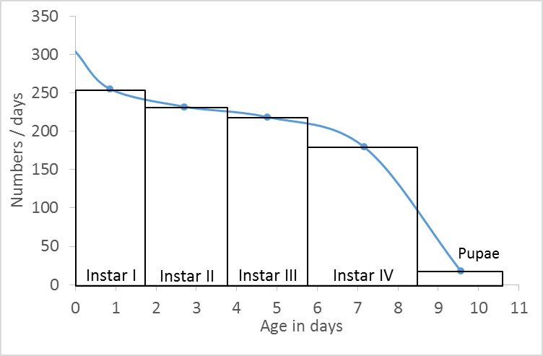

*Figure 16.* Age-distribution and survivorship curve for the immatures stages of *An. albimanus* in July of 2015 at Nuquí, Chocó, Colombia.

Own elaboration in Microsoft Excel (2012).

From this curve, the numbers of pre-adults surviving to each age in days, were obtained using WebPlotDigitizer (Rohatgi, 2013), to construct a life-table (Table 5) following the method of Service (1971) mentioned in Silver (2008). With comparative purposes, the numbers in are scaled up in the next column to start the life-table with a population of 1000 individuals. This value is then used to compute , , , and , following the formulas presented in Carey (2001).

Table 5. *Life table for An. albimanus immatures at Nuquí, Chocó, Colombia.*

|  |  |  |  |  |  |  |
| --- | --- | --- | --- | --- | --- | --- |
| **Age [days]** | **Number living** | **Fraction surviving** | **Frequency of deaths** | **Period survival** | **Period mortality** | **Expectation of life [days]** |
|  |  |  |  |  |  |  |
| 0 | 302 | 1000.00 | 169.42 | 0.83 | 0.17 | 6.33 |
| 1 | 251 | 830.58 | 42.36 | 0.95 | 0.05 | 6.52 |
| 2 | 238 | 788.22 | 28.46 | 0.96 | 0.04 | 5.84 |
| 3 | 230 | 759.76 | 16.88 | 0.98 | 0.02 | 5.04 |
| 4 | 225 | 742.89 | 25.48 | 0.97 | 0.03 | 4.14 |
| 5 | 217 | 717.41 | 33.75 | 0.95 | 0.05 | 3.27 |
| 6 | 207 | 683.65 | 70.81 | 0.90 | 0.10 | 2.41 |
| 7 | 185 | 612.84 | 175.05 | 0.71 | 0.29 | 1.63 |
| 8 | 132 | 437.79 | 245.86 | 0.44 | 0.56 | 1.08 |
| 9 | 58 | 191.93 | 129.05 | 0.33 | 0.67 | 0.83 |
| 10 | 19 | 62.87 | 62.87 | 0.00 | 1.00 | 0.50 |
| 11 | 0 | 0 | 0.00 | 0.00 | 1.00 | 0.00 |

*Note:* Own elaboration in Microsoft Excel (2012).

Figure 16 was also used to obtain the numbers entering to each instar with WebPlotDigitizer (Rohatgi, 2013), to estimate the mortalities of each stage (Table 6) following the method of Service (1971) mentioned in Silver (2008).

Table 6. *Instar mortalities of An. albimanus immatures at Nuquí, Chocó, Colombia.*

|  |  |  |  |  |  |
| --- | --- | --- | --- | --- | --- |
| **Stage** | **Age at the beginning of the stage** | **No. entering stage** | **Deaths in stage** | **Relative proportion dying in stage** | **Accumulated Mortality Fraction** |
|  |  |  |  |  |  |
| **Instar I** | 0 | 302 | 62 | 0.21 |  |
| **Instar II** | 1.7 | 240 | 15 | 0.06 | 0.21 |
| **Instar III** | 3.7 | 225 | 15 | 0.07 | 0.25 |
| **Instar IV** | 5.8 | 210 | 113 | 0.54 | 0.30 |
| **Pupae** | 8.5 | 97 | 78 | 0.80 | 0.68 |
| **Adult** | 10.6 | 19 |  |  | 0.94 |

*Note:* Own elaboration in Microsoft Excel (2012).

In addition, the life-table constructed in this study (Table 5) was used to estimate the average daily mortality (Table 7), which is defined as the inverse of the life expectancy at birth (Carey, 2001). The confidence intervals of the air and water temperature of this study were constructed for a 95% of confidence level with the assumption of normality, and the ENSO phase was obtained from the NOAA (NOAA, n.d.).

Table 7. *Average daily mortality of An. albimanus immatures*

|  |  |  |  |  |
| --- | --- | --- | --- | --- |
| Study No. | Place and date |  | Mean () | ENSO |
| 1 | Nuquí, Colombia, July of 2015 (This study) |  | () | El Niño |
| 2 | María Chiquita, Panama, January to June of 1989 (González, 2005) |  | No data  () | La Niña |

*Note:* Own elaboration in Microsoft Excel (2012).

The main advantage of this study above the other is that predators weren´t controlled here, but in Gonzalez (2005) they were. This result in a more realistic representation of the *in situ* mortality of immatures mosquitoes, which is expected help to improve the performance of population-based, vector-host malaria models that account for climate in Colombia.

1. Annex: The non-linear effect of temperature on the life history traits of An. albimanus[1]

Here I estimate relevant functions that represent the effect of temperature on some life history traits of the immature and adult stages of *An.albimanus*. Published and unpublished data obtained in laboratory experiments with *An. albimanus* under different constant ambient temperatures (Rúa-Uribe, 2006a, 2006b) were used to estimate: the blood meal digestion rate, the oviposition percentage, and the survival rate of adults; and the development rate; and survival percentage of immatures. Observed data were fitted to previously proposed non-linear functions (Damos & Savopoulou-Soultani, 2012; Lardeux, Tejerina, Quispe, & Chavez, 2008; W. J. M. Martens, 1997; Régnière, Powell, Bentz, & Nealis, 2012). The fit was done with an ordinary least squares method, through an iterative algorithm using the Qti Plot software (Vasilief, 2014). The newly estimated functions can contribute to improve the robustness of a mathematical model that account for the mosquito population. All the data used to derive the results presented here are available in the folder “Bernal-García, Sebastian_MasterThesis/Annex B/” of the Malaria Colombia online Git-Hub repository (Bernal-García, 2017).

# **1. Temperature Dynamics in the Laboratory**

The data used for the estimation of the functions of immature forms of *An. albimanus* were obtained in the laboratory for constant air temperatures, with no water temperatures records (Rúa-Uribe, 2006b). Other life-table laboratory experiments with *Anopheles spp.* at constant temperatures have reported a difference between air and water temperature of 2ºC to 3ºC (Bayoh, 2001) and 0.5ºC to 1ºC (Lyons, Coetzee, & Chown, 2013). This differences could be explained by the size of the bowls used, the volume of water, the type of growth chambers used and other variances of the experiments. For this reason to estimate the corresponding water temperature at which the data of immature *An. albimanus* were obtained(Rúa-Uribe, 2006b), we assume a difference of 2ºC between air () and water temperature () as reported by Bayoh (2001) as follows:

|  |  |
| --- | --- |
|  | (B-1) |

The reasons for this choice are:

1. The in-field models used to estimate water temperature at mosquito breeding sites are useless, since temperature was constant in the laboratory, and variables such as wind and soil are absent in the laboratory experiments.
2. Bowl dimensions used by Bayoh (2001) (15cmx10cmx8cm) are similar to the bowls used by Rúa-Uribe (2006b) (15cmx27cmx7cm). Bowl dimensions of Lyons et al. (2013) are not presented.
3. The difference in the water volume is minor between Bayoh (2001) and Rúa-Uribe (2006b) studies, 300ml, than between Lyons et al. (2013) and Rúa-Uribe (2006b) experiments, 600ml.
4. In communications with the laboratory where Rúa-Uribe (2006b) performed his experiments, we were notified that the growth chamber used is nonfunctional, which prevent us to measure the water temperature.

This calculus made easy to compare life history traits between *Anopheles* species, which helps providing more data in the estimation process of some functions used to simulate the , as the reader will notice later on.

# Blood Meal Digestion Rate, Oviposition Percentage and Survival Rate of *An. albimanus* females

## 2.1 Blood Meal Digestion Rate (BMDR)

The BMDR represent the frequency with which the female laid their eggs, and is the inverse of the gonotrophic cycle duration. To estimate it, we used the gonotrophic cycle duration obtained in laboratory conditions with *An. albimanus* under constant temperatures of 24ºC, 25.5ºC, 27ºC, 28.5ºC, and 30ºC (Rúa-Uribe, 2006b; Rúa-Uribe et al., 2005); and with *An. pseudocuntipennis* at 15ºC, 20ºC, 35ºC and 37ºC (Lardeux, Tejerina, Quispe, & Chavez, 2008). Both species are important malaria vectors of the subgenus Nyssorhynchus, in the Neotropic (Sinka et al., 2010). This data was fitted to a previously estimated nonlinear function of BMDR(Lardeux et al., 2008), which resulted in a new function of *An. albimanus* BMDR (*Figure 17*).

*Figure 17.* Blood Meal Digestion Rate of *An. albimanus* at constant air temperature

Own elaboration in Microsoft Excel (2012) with data from Lardeux et al. (2008), Rúa-Uribe (2006b) and Rúa-Uribe et al. (2005).

The fit was done iterating 4 times the Levenberg-Marquardt algorithm with a tolerance of 0.0001 in the QtiPlot software (Vasilief, 2014). Virtuous goodness of fit were obtained for the new function (, , ):

|  |  |
| --- | --- |
|  | (B-2) |

## 2.2 Oviposition Percentage (OP)

The percentage of *An. albimanus* females that oviposit at constants air temperatures of 18ºC, 20ºC, 26ºC, 28ºC, and 30ºC (Quimbayo Forero, 2006) were fitted to a second grade polynomial in the QtiPlot software (Vasilief, 2014) iterating 2 times the Levenberg-Marquardt algorithm with a tolerance of 0,0001 (, , ). We also include 37ºC to help the algorithm to find the best fit, considering that at this temperature all females die, and the percentage of oviposition at this air temperature is zero (Lardeux et al., 2008). The resulting function is equation B-3 and can be seen in *Figure 18*.

*Figure 18.* Oviposition Percentage of *An. albimanus* at constant air temperature

Own elaboration in Microsoft Excel (2012), with data from Lardeux et al. (2008) and Quimbayo Forero (2006).

|  |  |
| --- | --- |
|  | (B-3) |

## 2.3 Female Survival Rate (FSR)

The FSR is the probability that an *Anopheles albimanus* female mosquito survives one day regardless of its age. Unpublished life tables of *Anopheles albimanus* obtained in the laboratory for constant air temperatures of 24°C, 27°C, 30°C and 33°C (Rúa-Uribe, 2006a), were used to estimate the average daily mortality () (Carey, 2001). To estimate the lower temperature threshold of *An. albimanus,* the reported temperature for *An. spp.* (Craig, Le Sueur, & Snow, 1999), *An. gambiae* (Bayoh, 2001), *An. arabiensis*, and *An. funestus* (Lyons, Coetzee, Terblanche, & Chown, 2012) was averaged, resulting in 0ºC. Similarly the upper temperature threshold reported for *An. gambiae* (Bayoh, 2001; Kirby & Lindsay, 2007), *An. pseudocuntipennis* (Lardeux et al., 2008), *An. arabiensis*, and *An. funestus* (Lyons et al., 2012), was averaged resulting in 38ºC.

Then, the average daily survival () was calculated as , and fitted to the *Anopheles spp*. daily survival probability function proposed by W.J.M. Martens (W. J. M. Martens, 1997) to estimate the FSR. The fit was done in the Qti Plot software (Vasilief, 2014) iterating 97 times the Nelder-Mead Simplex algorithm with a tolerance of 0.0001. Virtuous goodness of fit were obtained (, , ) for the resulting function in equation B-4 and shown in *Figure 19*.

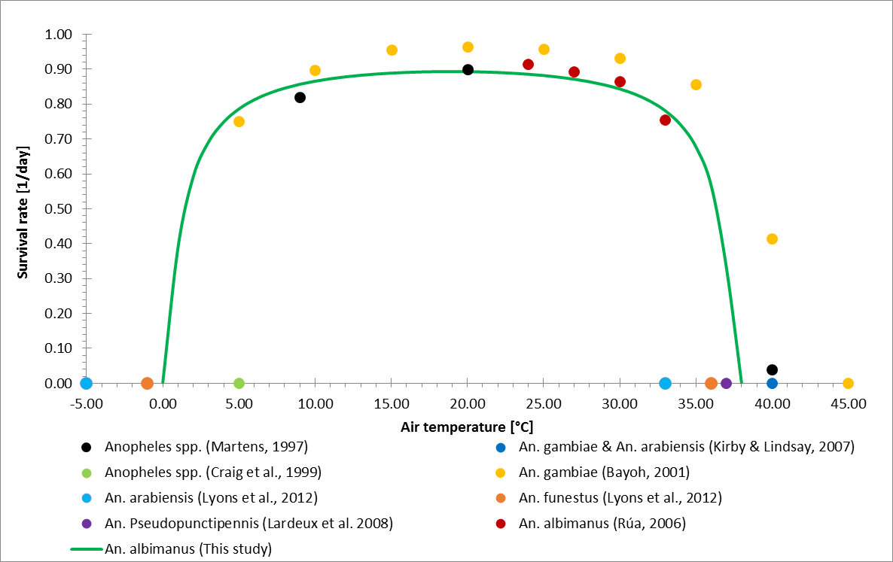

*Figure 19.* *An. albimanus* female survival rate under constant temperatures.

Own elaboration in Microsoft Excel (2012) with data from Bayoh (2001), Craig, Le Sueur, & Snow (1999), Kirby & Lindsay (2007), Lardeux et al. (2008), Lyons et al. (2012), Martens (1997), and Rúa-Uribe (2006a).

|  |  |
| --- | --- |
|  | (B-4) |

**With the aim of highlight the goodness of the function estimated, Figure 20 presents it, alongside others proposals (Ermert et al., 2011a; Lunde, Bayoh, & Lindtjørn, 2013).**

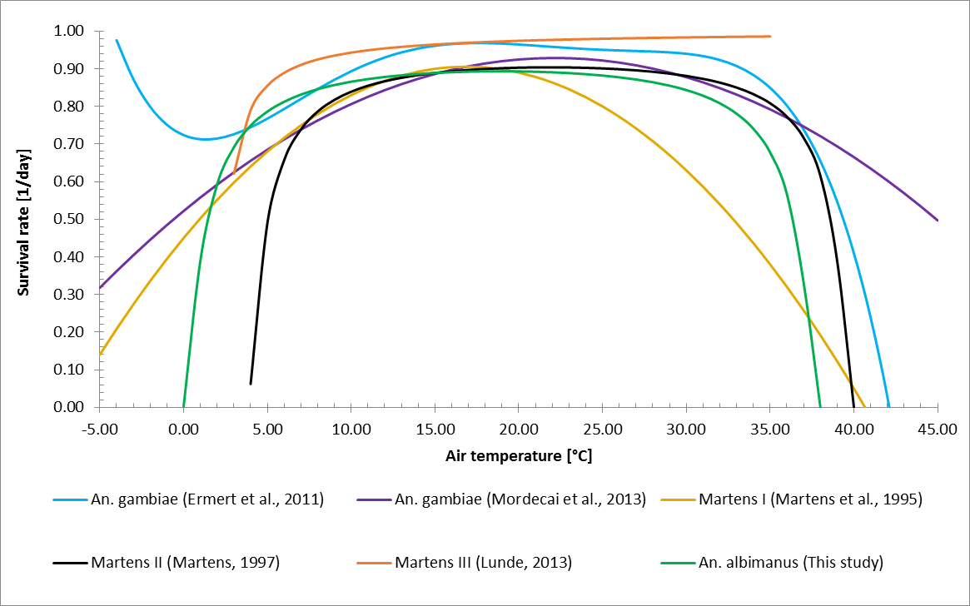

*Figure 20.* Female survival functions of different *Anopheles* species under constant air temperatures.

Own elaboration in Microsoft Excel (2012) with data from Ermert et al. (2011a), Lunde et al. (2013), Martens (1997), Martens et al. (1995), and Mordecai et al. (2013).

# The Development Rate and Survival Percentage of *An. albimanus* immatures

## 3.1 The Development Rate

### 3.1.1 Larvae

Larvae development times estimated for constant water (air) temperatures of 22ºC (24ºC), 25ºC (27ºC), 28ºC (30ºC), 31ºC (33ºC) (Rúa-Uribe, 2006b), 15°C and 35°C (Shelton, 1973) were fitted to the Lactin non-linear theoretical function (Damos & Savopoulou-Soultani, 2012; Régnière, Powell, Bentz, & Nealis, 2012). The fit was done in the QtiPlot software (Vasilief, 2014) iterating the Levenberg-Marquardt algorithm with a tolerance of 0,0001. This results in the following equation:

|  |  |
| --- | --- |
|  | (B-5) |

That as observed in *Figure 21*, have a good fit to the experimental data (, , ).

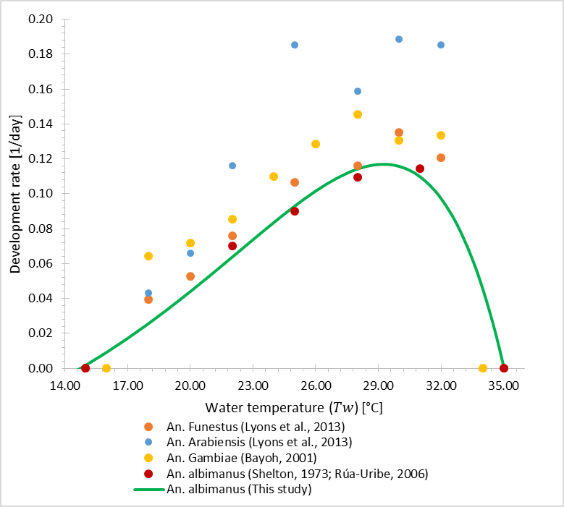

*Figure 21. An. Albimanus* larvae development rates under constant water temperatures.

Own elaboration in Microsoft Excel (2012) with data from Bayoh (2001), Lyons et al. (2013), Rúa-Uribe (2006b), and Shelton (1973).

### 3.1.2 Pupae

Pupae development times estimated for constant water (air) temperatures of 22ºC (24ºC), 25ºC (27ºC), 28ºC (30ºC), 31ºC (33ºC) (Rúa-Uribe, 2006b), 15°C and 35°C (Shelton, 1973) were fitted to the Briere non-linear theoretical function (Damos & Savopoulou-Soultani, 2012; Régnière et al., 2012). The fit was done in the QtiPlot software (Vasilief, 2014) iterating 128 times the Nelder-Mead Simplex algorithm with a tolerance of 0,0001. This results in the following equation:

|  |  |
| --- | --- |
|  | (B-6) |

That as observed in *Figure 22*, have a good fit to the experimental data (, , ).

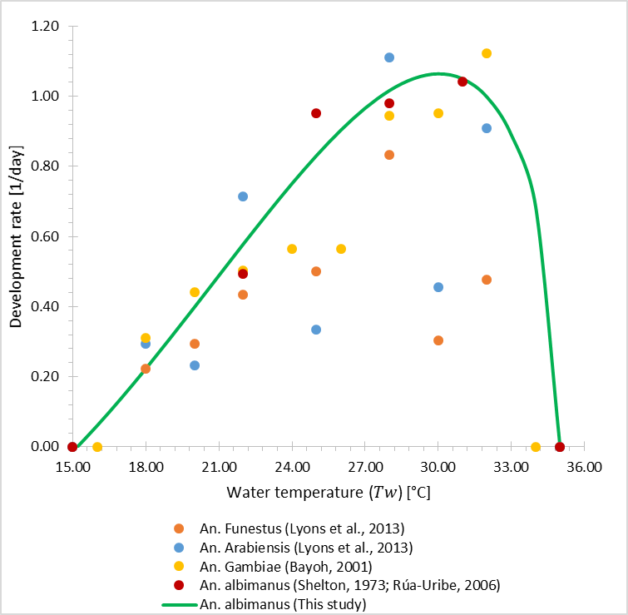

*Figure 22. An. Albimanus* pupae development rates under constant water temperatures.

Own elaboration in Microsoft Excel (2012) with data from Bayoh (2001), Lyons et al. (2013), Rúa-Uribe (2006b), and Shelton (1973).

## 3.2 Survival Percentage

The percent of *An. albimanus* larvae that survive to Adults estimated in laboratory conditions for constant water (air) temperatures of 22ºC (24ºC), 25ºC (27ºC), 28ºC (30ºC), 31ºC (33ºC) (Rúa-Uribe, 2006b), 15°C and 35°C (Shelton, 1973) were fitted to the Briere 2 non-linear theoretical function (Damos & Savopoulou-Soultani, 2012; Régnière et al., 2012). The fit was done in the QtiPlot software (Vasilief, 2014) iterating 108 times the Nelder-Mead Simplex algorithm with a tolerance of 0,0001. This results in the following equation:

|  |  |
| --- | --- |
|  | (B-7) |

That as observed in *Figure 23*, have a good fit to the experimental data (, , )

*Figure 23. An. albimanus* immature survival percentages under constant water temperatures.

Own elaboration in Microsoft Excel (2012) with data from Rúa-Uribe (2006a), and Shelton (1973).

1. Annex: An explicit vector model

Here the objective is to formulate the model rather than to simulate it, which is not done, but included as a recommendation for future work. The main equations of an explicit vector model, named hereafter , are in Table 8, while the description of the main parameters in Table 9.

Table 8. *Variables* *of the* .

|  |  |  |  |
| --- | --- | --- | --- |
| **Variable** | **Equation** | **Units** |  |
| Immatures |  |  | (C-1) |
| Susceptible Vectors |  |  | (C-2) |
| Exposed Vectors |  |  | (C-3) |
| Infected Vectors |  |  | (C-4) |
| Recruitment |  |  | (C-5) |
| Total Mosquitoes |  |  | (C-6) |
| Carrying Capacity Conditional |  |  | (C-7) |
| Immatures  Mortality Percent |  |  | (C-8) |
| Emergence |  |  | (C-9) |
| Immature Development Rate |  |  | (C-10) |
| Mosquito Mortality Rate |  |  | (C-11) |

*Note:* Own elaboration

The remaining equations and parameters, are described in the text. **The c**arrying capacity () definition is inspired by a balance equation for surface water proposed by Alonso et al. (2011), and take the following form:

|  |  |
| --- | --- |
|  | (C-12) |

Where is the water fallen per unit area a unit of time (Figure 9), is the carrying capacity decaying rate, and a function that transforms daily precipitation into a rate of increase per day of larval carrying capacity. Here the simple proportionality has been assumed, although more complex one have been considered elsewhere. is a factor that transforms daily precipitation into a rate of increase per day of larval carrying capacity.

Table 9. *Parameters of the* .

|  |  |  |  |
| --- | --- | --- | --- |
| **Symbol** | **Parameter** | **Value** | **Units** |
|  | Initial immatures | - |  |
|  | Initial Carrying Capacity | - |  |
|  | Initial susceptible mosquitoes | - |  |
|  | Initial exposed mosquitoes | - |  |
|  | Initial infected mosquitoes | - |  |
|  | Fecundity factor | - |  |
|  | Female percent | 0.5 |  |
|  | Infectivity of humans | - |  |
|  | Infectivity of mosquitoes | - |  |

*Note:* Own elaboration

**Unknown parameters of the**  (Table 9) **could be estimated with the same methodology used for the** , fitting the model to the data of *Figure 11*.

The parameter , is the immature survival percent estimated in the field, which is equal to (Table 6). In the other hand, , is the function (Equation B-7) evaluated in the temperature at which the parameter was obtained , which is presented in Table 7.

The force of infection that susceptible mosquitoes felt to move from to is given by:

|  |  |
| --- | --- |
|  | (C-13) |

And finally, the final piece of the puzzle to have a fully coupled mosquito-human Model of Climate and Malaria Incidence in Colombia, the force of infection that humans felt:

|  |  |
| --- | --- |
|  | (C-14) |

Which should replace the force of infection described in equation 4-6 to allow an effective interaction of mosquitoes and human populations.

Although the objective of this thesis was to formulate a physically-based equation, after revising the texts that provide the theoretical foundations to the vector-borne mathematical models (Aron & May, 1982; Keeling & Rohani, 2008), I found that this term is dimensionally inadequate. This could be due to an incomplete notation as is the case of others key concepts of the vector-borne infections theory (Eduardo Massad & Coutinho, 2012). Other plausible explanations include misinterpretation by my part of the units of the parameters involved, and a lack of dimensional analysis in the field of vector-borne pathogen transmission mathematical models. For this reason I introduce a dimensionality constant, , to give units of . Otherwise, would have units of , which would derive in a dimensional inconsistent model. Hence, a dimensional consistent force of infection for humans should be similar to that of mosquitoes, with the following form (Ngarakana-Gwasira, Bhunu, & Mashonjowa, 2014):

|  |  |
| --- | --- |
|  | (C-15) |

Bibliography

Alonso, D., Bouma, M. J., & Pascual, M. (2011). Epidemic malaria and warmer temperatures in recent decades in an East African highland. *Proceedings of the Royal Society B: Biological Sciences*, *278*(1712), 1661–1669. http://doi.org/10.1098/rspb.2010.2020

Anderson, R. M., & May, R. M. (1991). *Infectious Diseases of Humans: Dynamics and Control*. Oxford University Press.

Aron, J. L., & May, R. M. (1982). The population dynamics of malaria. In *The Population Dynamics of Infectious Diseases: Theory and Applications* (pp. 139–179). Boston, MA: Springer US. http://doi.org/10.1007/978-1-4899-2901-3_5

Artzy-Randrup, Y., Alonso, D., & Pascual, M. (2010). Transmission Intensity and Drug Resistance in Malaria Population Dynamics: Implications for Climate Change. *PLoS ONE*, *5*(10), e13588. http://doi.org/10.1371/journal.pone.0013588

Asare, E. O., Tompkins, A. M., Amekudzi, L. K., & Ermert, V. (2016). A breeding site model for regional, dynamical malaria simulations evaluated using in situ temporary ponds observations. *Geospatial Health*, *11*(1s). http://doi.org/10.4081/gh.2016.390

Asare, E. O., Tompkins, A. M., & Bomblies, A. (2016). A regional model for malaria vector developmental habitats evaluated using explicit, pond-resolving surface hydrology simulations. *PLoS ONE*, *11*(3). http://doi.org/10.1371/journal.pone.0150626

Ashley, E. A., & White, N. J. (2014). The duration of Plasmodium falciparum infections. *Malaria Journal*, *13*(1), 500. http://doi.org/10.1186/1475-2875-13-500

Atkinson, J.-A., Wells, R., Page, A., Dominello, A., Haines, M., & Wilson, A. (2015). Applications of system dynamics modelling to support health policy. *Public Health Research & Practice*, *25*(3), 1–8. http://doi.org/10.17061/phrp2531531

Baeza, A., Bouma, M. J., Dhiman, R., & Pascual, M. (2014). Malaria control under unstable dynamics: Reactive vs. climate-based strategies. *Acta Tropica*, *129*(null), 42–51. http://doi.org/10.1016/j.actatropica.2013.04.001

Bailey, N. T. J. (1982). *The biomathematics of malaria*. London: Charles Griffin & Company Limited.

Barlas, Y. (1996). Formal aspects of model validity and validation in system dynamics. *System Dynamics Review*, *12*(3), 183–210. http://doi.org/10.1002/(SICI)1099-1727(199623)12:3<183::AID-SDR103>3.0.CO;2-4

Bayoh, M. N. (2001). *Studies on the development and survival of anopheles gambiae sensu stricto at various temperatures and relative humidities*. Durham University. Retrieved from http://etheses.dur.ac.uk/4952/

Bernal-García, S. (2017). Malaria Colombia. Retrieved October 10, 2017, from https://github.com/sebastbernal/MalariaColombia

Bernal-García, S., Díez-Echavarría, L., Arango-Aramburo, S., Suaza-Vasco, J., Uribe-Soto, S., Jaramillo, L., & Poveda, G. (2014). An Improved Mathematical Model of Malaria Incidence in Colombia. In *WCRP Conference for Latin America and the Caribbean: Developing, linking, and applying climate knowledge.* Montevideo: World Climate Research Programme. http://doi.org/10.13140/2.1.5192.6725

Bernal-García, S., Díez-Echavarría, L., Arango-Aramburo, S., Suaza-Vasco, J., Uribe-Soto, S., & Poveda, G. (2015). A New System Dynamics Model of Climate and Malaria Incidence in Colombia. In *Second International & Interdisciplinary Workshop on Mathematical Modeling, Ecology, Evolution and Dynamics of Dengue and Related Diseases (IIWEE)*. Villa de Leyva, Colombia: Universidad de los Andes & Arizona State University. http://doi.org/10.13140/RG.2.2.19240.67845

Bernal-García, S., Diez, L., Arango-Aramburo, S., Suaza-Vasco, J., Uribe-Soto, S., & Poveda, G. (2017). The non-linear effect of temperature on the development and survival of An. albimanus, a dominant malaria vector of the Americas. In *Second Conference on Impacts of Environmental Changes on Infectious Diseases (IECID)*. Trieste. Italy: Elsevier. http://doi.org/10.13140/RG.2.2.29307.00807

Bhadra, A., Ionides, E. L., Laneri, K., Pascual, M., Bouma, M., & Dhiman, R. C. (2011). Malaria in Northwest India: Data Analysis via Partially Observed Stochastic Differential Equation Models Driven by Lévy Noise. *Journal of the American Statistical Association*, *106*(494), 440–451. http://doi.org/10.1198/jasa.2011.ap10323

Bomblies, A. (2011). Modeling the role of rainfall patterns in seasonal malaria transmission. *Climatic Change*, *112*(3–4), 673–685. http://doi.org/10.1007/s10584-011-0230-6

Bomblies, A., Duchemin, J.-B., & Eltahir, E. a B. (2008). Hydrology of malaria: Model development and application to a Sahelian village. *Water Resources Research*, *44*(12), 1–26. http://doi.org/10.1029/2008WR006917

Bomblies, A., & Eltahir, E. a B. (2009). Assessment of the impact of climate shifts on malaria transmission in the Sahel. *EcoHealth*, *6*(3), 426–37. http://doi.org/10.1007/s10393-010-0274-5

Boulanger, J.-P., Buckeridge, M. S., Castellanos, E., Poveda, G., Scarano, F. R., & Vicuña, S. (2014). Central and South America. In *Climate Change 2014: Impacts, Adaptation, and Vulnerability. Volume II: Regional Aspects. Contribution of Working Group II to the Fifth Assessment Report of the Intergovernmental Panel on Climate Change* (pp. 1–102). Cambridge University Press, Cambridge, United Kingdom and New York, NY, USA.

Bouma, M. J., Poveda, G., Rojas, W., Chavasse, D., Quiñones, M., Cox, J., & Patz, J. (1997). Predicting high-risk years for malaria in Colombia using parameters of El Niño Southern Oscillation. *Tropical Medicine & International Health : TM & IH*, *2*(12), 1122–7. Retrieved from http://www.ncbi.nlm.nih.gov/pubmed/9438466

Boyd, M. F., & Kitchen, S. F. (1937). The Duration of the Intrinsic Incubation Period in Falciparum Malaria in Relation to Certain Factors Affecting the Parasites. *The American Journal of Tropical Medicine and Hygiene*, *s1*-*17*(6), 845–848. http://doi.org/10.4269/ajtmh.1937.s1-17.845

Brauer, F., & Castillo-Chavez, C. (2011). *Mathematical Models in Population Biology and Epidemiology* (2nd ed.). http://doi.org/10.1007/978-1-4614-1686-9

Brauer, F., Castillo-Chavez, C., De La Pava, E., Barley, K., Castillo-Garsow, C. W., Chowell, D., … Moreno. (2014). *Modelos de la Propagación de Enfermedades Infecciosas*. Cali: Universidad Autónoma de Occidente.

Caminade, C., Kovats, S., Rocklov, J., Tompkins, A. M., Morse, A. P., Colón-González, F. J., … Lloyd, S. J. (2014). Impact of climate change on global malaria distribution. *Proceedings of the National Academy of Sciences of the United States of America*, *111*(9), 3286–91. http://doi.org/10.1073/pnas.1302089111

Caminade, C., Ndione, J. A., Kebe, C. M. F., Jones, A. E., Danuor, S., Tay, S., … Morse, A. P. (2011). Mapping Rift Valley fever and malaria risk over West Africa using climatic indicators. *Atmospheric Science Letters*, *12*(1), 96–103. http://doi.org/10.1002/asl.296

Carey, J. R. (2001). Insect biodemography. *Annual Review of Entomology*, *46*, 79–110. http://doi.org/10.1146/annurev.ento.46.1.79

Carvajal, H., de Herrera, M. a, Quintero, J., Alzate, a, & Herrera, S. (1989). Anopheles neivai: a vector of malaria in the Pacific lowlands of Colombia. *Transactions of the Royal Society of Tropical Medicine and Hygiene*, *83*(5), 609. Retrieved from http://www.ncbi.nlm.nih.gov/pubmed/2694501

Centers for Disease Control and Prevention. (n.d.). Malaria Parasites. Retrieved December 11, 2013, from http://www.cdc.gov/malaria/about/biology/parasites.html

Chitnis, N., Schapira, A., Smith, D. L., Smith, T., Hay, S. I., & Steketee, R. (2010). *Mathematical modelling to support malaria control and elimination*.

Chitnis, N., Schapira, A., Smith, T., & Steketee, R. (2010). Comparing the Effectiveness of Malaria Vector-Control Interventions Through a Mathematical Model. *The American Journal of Tropical Medicine and Hygiene*, *83*(2), 230–240. http://doi.org/10.4269/ajtmh.2010.09-0179

Chiyaka, C., Garira, W., & Dube, S. (2007). Transmission model of endemic human malaria in a partially immune population. *Mathematical and Computer Modelling*, *46*(5–6), 806–822. http://doi.org/10.1016/j.mcm.2006.12.010

Cook, J., Nuccitelli, D., Green, S. A., Richardson, M., Winkler, B., Painting, R., … Skuce, A. (2013). Quantifying the consensus on anthropogenic global warming in the scientific literature. *Environmental Research Letters*, *8*(2), 24024. http://doi.org/10.1088/1748-9326/8/2/024024

Craig, M., Le Sueur, D., & Snow, B. (1999). A climate-based distribution model of malaria transmission in sub-Saharan Africa. *Parasitology Today*, *15*(3), 105–111. http://doi.org/10.1016/S0169-4758(99)01396-4

Crutzen, P. J. (2006). The “Anthropocene.” In *Earth System Science in the Anthropocene* (pp. 13–18). Berlin/Heidelberg: Springer-Verlag. http://doi.org/10.1007/3-540-26590-2_3

Damos, P., & Savopoulou-Soultani, M. (2012). Temperature-Driven Models for Insect Development and Vital Thermal Requirements. *Psyche: A Journal of Entomology*, *2012*, 1–13. http://doi.org/10.1155/2012/123405

DANE. (n.d.). Colombia. Indicadores demográficos según departamento 1985-2020. Retrieved December 8, 2013, from http://www.dane.gov.co/files/investigaciones/poblacion/seriesp85_20/IndicadoresDemograficos1985-2020.xls

DANE. (2011). Estimación y proyección de población nacional, departamental y municipal total por área 1985-2020. Retrieved December 8, 2013, from http://www.dane.gov.co/files/investigaciones/poblacion/proyepobla06_20/Municipal_area_1985-2020.xls

Departamento Administrativo Nacional de Estadistica (DANE). (2012). Pobreza en Colombia. Bogotá D.C.: Oficina de Prensa DANE.

Dietz, K. (1988). Mathematical models for transmission and control of malaria. In W. H. Wernsdorfer & I. McGregor (Eds.), *Malaria: principles and practice of malariology* (pp. 1091–1133). Edinburgh: Churchill Livingstone.

Dizikes, P. (2015). The Many Careers of Jay Forrester. Retrieved May 30, 2016, from https://www.technologyreview.com/s/538561/the-many-careers-of-jay-forrester/

Ermert, V., Fink, A. H., Jones, A. E., & Morse, A. P. (2011a). Development of a new version of the Liverpool Malaria Model. I. Refining the parameter settings and mathematical formulation of basic processes based on a literature review. *Malaria Journal*, *10*(1), 35. http://doi.org/10.1186/1475-2875-10-35

Ermert, V., Fink, A. H., Jones, A. E., & Morse, A. P. (2011b). Development of a new version of the Liverpool Malaria Model. II. Calibration and validation for West Africa. *Malaria Journal*, *10*(1), 35. http://doi.org/10.1186/1475-2875-10-35

Ermert, V., Fink, A. H., & Paeth, H. (2013). The potential effects of climate change on malaria transmission in Africa using bias-corrected regionalised climate projections and a simple malaria seasonality model. *Climatic Change*, *120*(4), 741–754. http://doi.org/10.1007/s10584-013-0851-z

Felger, I., Maire, M., Bretscher, M. T., Falk, N., Tiaden, A., Sama, W., … Smith, T. A. (2012). The Dynamics of Natural Plasmodium falciparum Infections. *PLoS ONE*, *7*(9), 1–10. http://doi.org/10.1371/journal.pone.0045542

Field, C. B., Barros, V. R., Dokken, D. J., Mac, K. J., Mastrandrea, M. D., Bilir, T. E., … White, L. L. (Eds.). (2014). IPCC, 2014: Summary for Policymakers. In *Climate Change 2014: Impacts, Adaptation, and Vulnerability. Part A: Global and Sectoral Aspects. Contribution of Working Group II to the Fifth Assessment Report of the Intergovernmental Panel on Climate Change* (pp. 1–32). Cambridge University Press, Cambridge, United Kingdom and New York, NY, USA. Retrieved from http://ipcc-wg2.gov/AR5/images/uploads/WG2AR5_SPM_FINAL.pdf

Filipe, J. A. N., Riley, E. M., Drakeley, C. J., Sutherland, C. J., & Ghani, A. C. (2007). Determination of the Processes Driving the Acquisition of Immunity to Malaria Using a Mathematical Transmission Model. *PLoS Computational Biology*, *3*(12), e255. http://doi.org/10.1371/journal.pcbi.0030255

Flessa, S. (1999). Decision support for malaria-control programmes--a system dynamics model. *Health Care Management Science*, *2*(3), 181–91. Retrieved from http://www.ncbi.nlm.nih.gov/pubmed/10934542

Focks, D. A., Daniels, E., Haile, D. G., & Keesling, J. E. (1995). A simulation model of the epidemiology of urban dengue fever: literature analysis, model development, preliminary validation, and samples of simulation results. *The American Journal of Tropical Medicine and Hygiene*, *53*(5), 489–506. Retrieved from http://www.ncbi.nlm.nih.gov/pubmed/7485707

Focks, D. A., Haile, D. G., Daniels, E., & Mount, G. A. (1993a). Dynamic Life Table Model for Aedes aegypti (Diptera: Culicidae): Analysis of the Literature and Model Development. *Journal of Medical Entomology*, *30*(6), 1003–1017. http://doi.org/10.1093/jmedent/30.6.1003

Focks, D. A., Haile, D. G., Daniels, E., & Mount, G. A. (1993b). Dynamic Life Table Model for Aedes aegypti (Diptera: Culicidae): Simulation Results and Validation. *Journal of Medical Entomology*, *30*(6), 1018–1028. http://doi.org/10.1093/jmedent/30.6.1018

Foppa, I. M. (2017). *A Historical Introduction to Mathematical Modeling of Infectious Diseases*. Academic Press. Retrieved from http://www.sciencedirect.com/science/book/9780128022603

Forrester, J. W. (1989). The Beginning of System Dynamics. *Banquet Talk at the International Meeting of the System Dynamics Society Stuttgart*, 1–16.

Forrester, J. W. (1995). Counterintuitive behavior of social systems. *Collected Papers of Jay W. Forrester*, 1–22. http://doi.org/10.1016/S0040-1625(71)80001-X

Forrester, J. W., & Senge, P. M. (1980). Tests for building confidence in system dynamics models. *TIMS Studies in the Management Sciences*, *14*(1), 209–228.

Garret-Jones, C. (1964). The Human Blood Index of Malaria Vectors in Relation to Epidemiological Assessment. *Bulletin of the World Health Organization*, *30*, 241–61. Retrieved from http://www.pubmedcentral.nih.gov/articlerender.fcgi?artid=2554803&tool=pmcentrez&rendertype=abstract

González, R. (2005). Efecto del criadero sobre la duración del ciclo de vida y productividad de Anopheles albimanus Wiedemann (Diptera: Culicidae). *Boletín Del Museo de Entomología de La Universidad Del Valle*, *6*(1), 1–6.

Gu, W., Regens, J. L., Beier, J. C., & Novak, R. J. (2006). Source reduction of mosquito larval habitats has unexpected consequences on malaria transmission. *Proceedings of the National Academy of Sciences of the United States of America*, *103*(46), 17560–3. http://doi.org/10.1073/pnas.0608452103

Gutiérrez, L. A. (2010). *Infectividad natural por Plasmodium spp. de Anopheles spp. (Diptera: Culicidae) y estructura genética poblacional de Anopheles albimanus y Anopheles darlingi, en Colombia*. Universidad de Antioquia.

Gutiérrez, L. A., González, J. J., Gómez, G. F., Castro, M. I., Rosero, D. A., Luckhart, S., … Correa, M. M. (2009). Species composition and natural infectivity of anthropophilic Anopheles (Diptera: Culicidae) in the states of Córdoba and Antioquia, Northwestern Colombia. *Memórias Do Instituto Oswaldo Cruz*, *104*(8), 1117–24. Retrieved from http://www.pubmedcentral.nih.gov/articlerender.fcgi?artid=3066193&tool=pmcentrez&rendertype=abstract

Gutiérrez, L. A., Naranjo, N. J., Cienfuegos, A. V, Muskus, C. E., Luckhart, S., Conn, J. E., & Correa, M. M. (2009). Population structure analyses and demographic history of the malaria vector Anopheles albimanus from the Caribbean and the Pacific regions of Colombia. *Malaria Journal*, *8*, 259. http://doi.org/10.1186/1475-2875-8-259

Gutiérrez, L. A., Naranjo, N., Jaramillo, L. M., Muskus, C., Luckhart, S., Conn, J. E., & Correa, M. M. (2008). Natural infectivity of Anopheles species from the Pacific and Atlantic Regions of Colombia. *Acta Tropica*, *107*(2), 99–105. http://doi.org/10.1016/j.actatropica.2008.04.019

Hirsch, G., & Homer, J. (2009). Health Care in the United States, System Dynamics Applications to. In *Complex Systems in Finance and Econometrics* (pp. 513–524). New York, NY: Springer New York. http://doi.org/10.1007/978-1-4419-7701-4_29

Homer, J. B., & Hirsch, G. B. (2006). System Dynamics Modeling for Public Health: Background and Opportunities. *American Journal of Public Health*, *96*(3), 452–458. http://doi.org/10.2105/AJPH.2005.062059

Hoshen, M. B., & Morse, A. P. (2004). A weather-driven model of malaria transmission. *Malaria Journal*, *3*(1), 32. Retrieved from http://www.malariajournal.com/content/3/1/32

Hoshen, M. B., & Morse, A. P. (2005). A model structure for estimating malaria risk. In W. Takken, P. Martens, & R. J. Bogers (Eds.), *Environmental Change and Malaria Risk: Global and Local Implications* (1st ed., pp. 41–50). Springer.

Jacobs, A. F. G., Heusinkveld, B. G., Kraai, A., & Paaijmans, K. P. (2008). Diurnal temperature fluctuations in an artificial small shallow water body. *International Journal of Biometeorology*, *52*(4), 271–280. http://doi.org/10.1007/s00484-007-0121-8

Janssen, M. A., & Martens, W. J. M. (1997). Modeling malaria as a complex adaptive system. *Artificial Life*, *3*(3), 213–36. Retrieved from http://www.ncbi.nlm.nih.gov/pubmed/9385735

Jetten, T. H., Martens, W. J. M., & Takken, W. (1996). Model Simulations To Estimate Malaria Risk Under Climate Change. *Journal of Medical Entomology*, *33*(3), 361–371. http://doi.org/10.1093/jmedent/33.3.361

Jones, A. E., & Morse, A. P. (2010). Application and Validation of a Seasonal Ensemble Prediction System Using a Dynamic Malaria Model. *Journal of Climate*, *23*(15), 4202–4215. http://doi.org/10.1175/2010JCLI3208.1

Keeling, M. J., & Rohani, P. (2008). *Modeling Infectious Diseases in Humans and Animals* (1st ed.). New Jersey: Princeton University Press. Retrieved from http://www.sciencedirect.com/science/article/B98GG-4T7XCGF-9D/2/95c40489e0e5ee3c0670ee1cf3f0e65f

Keeling, M. J., & Rohani, P. (2011). Introduction to simple epidemic models. In *Modeling Infectious Diseases in Humans and Animals.* (p. 385). Princeton University Press.

Kermack, W. O., & McKendrick, A. G. (1927). A Contribution to the Mathematical Theory of Epidemics. *Proceedings of the Royal Society of London. Series A*, *115*(772), 700–721. http://doi.org/10.1098/rspa.1927.0118

Kilpatrick, A. M., & Randolph, S. E. (2012). Drivers, dynamics, and control of emerging vector-borne zoonotic diseases. *The Lancet*, *380*(9857), 1946–1955. Retrieved from http://www.scopus.com/inward/record.url?eid=2-s2.0-84866563012&partnerID=40&md5=d59b3f9a0bef431f2a16ff1daf511afb

King, A. A., Ionides, E. L., Breto, C. M., Ellner, S. P., Ferrari, M. J., Kendall, B. E., … Wood, S. N. (2017). pomp: Statistical Inference for Partially Observed Markov Processes. Retrieved from http://kingaa.github.io/pomp

King, A. A., Nguyen, D., & Ionides, E. L. (2016). Statistical Inference for Partially Observed Markov Processes via the R Package pomp. *Journal of Statistical Software*, *69*(12). http://doi.org/10.18637/jss.v069.i12

Kirby, M. J., & Lindsay, S. W. (2007). Responses of adult mosquitoes of two sibling species, Anopheles arabiensis and A. gambiae s.s. (Diptera: Culicidae), to high temperatures. *Bulletin of Entomological Research*, *94*(5), 441–448. http://doi.org/10.1079/BER2004316

Kjellstrom, T., & McMichael, A. J. (2013). Climate change threats to population health and well-being: the imperative of protective solutions that will last. *Global Health Action*, *6*, 1–9. http://doi.org/http://dx.doi.org/10.3402/gha.v6i0.20816

Koella, J. C. (1991). On the use of mathematical models of malaria transmission. *Acta Tropica*, *49*(1), 1–25. http://doi.org/10.1016/0001-706X(91)90026-G

Laneri, K., Bhadra, A., Ionides, E. L., Bouma, M., Dhiman, R. C., Yadav, R. S., & Pascual, M. (2010). Forcing Versus Feedback: Epidemic Malaria and Monsoon Rains in Northwest India. *PLoS Computational Biology*, *6*(9), e1000898. http://doi.org/10.1371/journal.pcbi.1000898

Laneri, K., Paul, R. E., Tall, A., Faye, J., Diene-Sarr, F., Sokhna, C., … Rodó, X. (2015). Dynamical malaria models reveal how immunity buffers effect of climate variability. *Proceedings of the National Academy of Sciences of the United States of America*, *112*(28), 8786–91. http://doi.org/10.1073/pnas.1419047112

Lardeux, F. J., Tejerina, R. H., Quispe, V., & Chavez, T. K. (2008). A physiological time analysis of the duration of the gonotrophic cycle of Anopheles pseudopunctipennis and its implications for malaria transmission in Bolivia. *Malaria Journal*, *7*(1), 141. http://doi.org/10.1186/1475-2875-7-141

Lauderdale, J. M., Caminade, C., Heath, A. E., Jones, A. E., MacLeod, D. A., Gouda, K. C., … Morse, A. P. (2014). Towards seasonal forecasting of malaria in India. *Malaria Journal*, *13*(1). http://doi.org/10.1186/1475-2875-13-310

Levin, S. A., Hallam, T. G., & Gross, L. J. (Eds.). (1989). *Applied Mathematical Ecology* (Vol. 18). Berlin, Heidelberg: Springer Berlin Heidelberg. http://doi.org/10.1007/978-3-642-61317-3

Linard, C., Ponçon, N., Fontenille, D., & Lambin, E. F. (2009). A multi-agent simulation to assess the risk of malaria re-emergence in southern France. *Ecological Modelling*, *220*(2), 160–174. http://doi.org/10.1016/j.ecolmodel.2008.09.001

Lindsay, S. W., & Birley, M. H. (1996). Climate change and malaria transmission. *Annals of Tropical Medicine and Parasitology*, *90*(6), 573–588. Retrieved from http://www.scopus.com/inward/record.url?eid=2-s2.0-0030466019&partnerID=40&md5=c2afd0113a2cf5f15224fa296b6efa44

Lindsay, S. W., & Martens, W. J. M. (1998). Malaria in the African highlands: past, present and future. *Bulletin of the World Health Organization*, *76*(1), 33–45. Retrieved from http://www.pubmedcentral.nih.gov/articlerender.fcgi?artid=2305628&tool=pmcentrez&rendertype=abstract

Lloyd, A. L. (2001). Realistic Distributions of Infectious Periods in Epidemic Models: Changing Patterns of Persistence and Dynamics. *Theoretical Population Biology*, *60*(1), 59–71. http://doi.org/10.1006/tpbi.2001.1525

Lotka, A. J. (1923). CONTRIBUTION TO THE ANALYSIS OF MALARIA EPIDEMIOLOGY. I. GENERAL PART*. *American Journal of Epidemiology*, *3*(supp1), 1–36. http://doi.org/10.1093/oxfordjournals.aje.a118963

Lotka, A. J., & Sharpe, F. R. (1923). CONTRIBUTION TO THE ANALYSIS OF MALARIA EPIDEMIOLOGY. IV. INCUBATION LAG*. *American Journal of Epidemiology*, *3*(supp1), 96–112. http://doi.org/10.1093/oxfordjournals.aje.a118967

Lovejoy, S. (2014). Scaling fluctuation analysis and statistical hypothesis testing of anthropogenic warming. *Climate Dynamics*. http://doi.org/10.1007/s00382-014-2128-2

Luke, D., & Stamatakis, K. (2012). Systems science methods in public health: dynamics, networks, and agents. *Annual Review of Public Health*, *33*, 357–76. http://doi.org/10.1146/annurev-publhealth-031210-101222

Lunde, T. M., Bayoh, M. N., & Lindtjørn, B. (2013). How malaria models relate temperature to malaria transmission. *Parasites & Vectors*, *6*(1), 20. http://doi.org/10.1186/1756-3305-6-20

Lyons, C. L., Coetzee, M., & Chown, S. L. (2013). Stable and fluctuating temperature effects on the development rate and survival of two malaria vectors, Anopheles arabiensis and Anopheles funestus. *Parasites & Vectors*, *6*(1), 104. http://doi.org/10.1186/1756-3305-6-104

Lyons, C. L., Coetzee, M., Terblanche, J. S., & Chown, S. L. (2012). Thermal limits of wild and laboratory strains of two African malaria vector species, Anopheles arabiensis and Anopheles funestus. *Malaria Journal*, *11*(1), 226. http://doi.org/10.1186/1475-2875-11-226

Macdonald, G. (1950). The analysis of infection rates in diseases in which superinfection occurs. *Tropical Diseases Bulletin*, *47*(10), 907–15. Retrieved from http://www.ncbi.nlm.nih.gov/pubmed/14798656

Macdonald, G. (1952a). The analysis of equilibrium in malaria. *Tropical Diseases Bulletin*, *49*(9), 813–29. Retrieved from http://www.ncbi.nlm.nih.gov/pubmed/12995455

Macdonald, G. (1952b). The analysis of the sporozoite rate. *Tropical Diseases Bulletin*, *49*(6), 569–86. Retrieved from http://www.ncbi.nlm.nih.gov/pubmed/14958825

Macdonald, G. (1957). *The Epidemiology and Control of Malaria*. London: Oxford University Press. Retrieved from http://books.google.com.co/books/about/The_epidemiology_and_control_of_malaria.html?id=xMu2AAAAIAAJ&redir_esc=y

Mandal, S., Sarkar, R. R., & Sinha, S. (2011). Mathematical models of malaria - a review. *Malaria Journal*, *10*(1), 202. http://doi.org/10.1186/1475-2875-10-202

Mantilla, G., Oliveros, H., & Barnston, A. G. (2009). The role of ENSO in understanding changes in Colombia’s annual malaria burden by region, 1960-2006. *Malaria Journal*, *8*(1), 6. http://doi.org/10.1186/1475-2875-8-6

Martens, P., Kovats, R. S., Nijhof, S., Vries, P. De, Livermore, M. T. J., Bradley, D. J., … Mcmichael, A. J. (1999). Climate change and future populations at risk of malaria. *Global Environmental Change*, *9*, 89–107.

Martens, P., & Thomas, C. (2005). Climate change and malaria risk: complexity and scaling. In *Environmental Change and Malaria Risk: Global and Local Implications* (1st ed., pp. 3–14). Springer.

Martens, W. J. M. (1997). *Health impacts of climate change and ozone depletion: an eco-epidemiological modelling approach*. Maastricht University.

Martens, W. J. M. (1998). Health impacts of climate change and ozone depletion: an ecoepidemiologic modeling approach. *Environmental Health Perspectives*, *106*(Supplement 1), 241–251. Retrieved from http://www.ncbi.nlm.nih.gov/pubmed/1533278

Martens, W. J. M., Jetten, T. H., & Focks, D. A. (1997). SENSITIVITY OF MALARIA, SCHISTOSOMIASIS AND DENGUE TO GLOBAL WARMING. *Climatic Change*, *35*(2), 145–156. http://doi.org/10.1023/A:1005365413932

Martens, W. J. M., Jetten, T., Rotmans, J., & Niessen, L. (1995). Climate change and vector-borne diseases. *Global Environmental Change*, *5*(3), 195–209. http://doi.org/10.1016/0959-3780(95)00051-O

Martens, W. J. M., Niessen, L. W., Rotmans, J., Jetten, T. H., & Mcmichael, A. J. (1995). Potential Impact of Global Climate Change on Malaria Risk. *Environmental Health Perspectives*, *103*(5).

Massad, E., & Coutinho, F. A. B. (2012). Vectorial capacity, basic reproduction number, force of infection and all that: formal notation to complete and adjust their classical concepts and equations. *Memórias Do Instituto Oswaldo Cruz*, *107*(4), 564–7. Retrieved from http://www.ncbi.nlm.nih.gov/pubmed/22666873

Massad, E., & Forattini, O. P. (1998). Modelling the temperature sensitivity of some physiological parameters of epidemiologic significance. *Ecosystem Health*, *4*(2).

McMichael, A. J., & Lindgren, E. (2011). Climate change: Present and future risks to health, and necessary responses. *Journal of Internal Medicine*, *270*(5), 401–413. Retrieved from http://www.scopus.com/inward/record.url?eid=2-s2.0-80054030614&partnerID=40&md5=8be142b62014dd630b4d52dc1eaefdea

McMichael, A. J., Woodruff, R. E., & Hales, S. (2006). Climate change and human health: present and future risks. *Lancet*, *367*(9513), 859–69. Retrieved from http://dx.doi.org/10.1016/S0140-6736(06)68079-3

Mecoli, M., De Angelis, V., & Brailsford, S. C. (2013). Using system dynamics to evaluate control strategies for mosquito-borne diseases spread by human travel. *Computers & Operations Research*, *40*(9), 2219–2228. http://doi.org/10.1016/j.cor.2012.03.007

Meyers, R. A. (2011). *Complex Systems in Finance and Econometrics*. (R. A. Meyers, Ed.). New York, NY: Springer New York. http://doi.org/10.1007/978-1-4419-7701-4

Microsoft Corporation. (2012). Microsoft Excel 2013.

Montosi, E., Manzoni, S., Porporato, A., & Montanari, A. (2012). An eco-hydrologic model of malaria outbreaks. *Hydrology and Earth System Sciences Discussions*, *9*(3), 2831–2854. http://doi.org/10.5194/hessd-9-2831-2012

Montoya-Lerma, J., Solarte, Y. A., Giraldo-Calderón, G. I., Quiñones, M. L., Ruiz-López, F., Wilkerson, R. C., & González, R. (2011). Malaria vector species in Colombia: a review. *Memórias Do Instituto Oswaldo Cruz*, *106*, 223–238. Retrieved from http://www.scielo.br/scielo.php?script=sci_arttext&pid=S0074-02762011000900028&lng=en&nrm=iso&tlng=en

Mordecai, E. a, Paaijmans, K. P., Johnson, L. R., Balzer, C., Ben-Horin, T., de Moor, E., … Lafferty, K. D. (2013). Optimal temperature for malaria transmission is dramatically lower than previously predicted. *Ecology Letters*, *16*(1), 22–30. http://doi.org/10.1111/ele.12015

Morse, A. P., Doblas-Reyes, F. J., Hoshen, M. B., Hagedorn, R., & Palmer, T. N. (2005). A forecast quality assessment of an end-to-end probabilistic multi-model seasonal forecast system using a malaria model. *Tellus A: Dynamic Meteorology and Oceanography*, *57*(3), 464–475. http://doi.org/10.3402/tellusa.v57i3.14668

Murillo B., C., Jaramillo S., C., Quintero C., J., & Suarez T., M. (1989). Biologia de Anopheles (kerteszia) neivai H., D. & K., 1913 (Diptera: culicidae) en la costa pacifica de colombia: IV. Estrucutra etárea y transmisión de la malaria. *Revista de Saúde Pública*, *23*(5), 363–367.

Naranjo-Diaz, N., Rosero, D. a, Rúa-Uribe, G., Luckhart, S., & Correa, M. M. (2013). Abundance, behavior and entomological inoculation rates of anthropophilic anophelines from a primary Colombian malaria endemic area. *Parasites & Vectors*, *6*(1), 61. http://doi.org/10.1186/1756-3305-6-61

Newman, J., Martin, L., Velasco, M. A., & Fantini, A.-M. (2003). A system dynamics approach to monitoring and evaluation at the country level : An aplication to the evaluation of malaria-control programs in Bolivia. In *Fifth Biennial World Bank Conference on Evaluation and Development “Evaluating Development Effectiveness: challanges and the Way Forward”* (pp. 1–16). Washington.

Ngarakana-Gwasira, E. T., Bhunu, C. P., & Mashonjowa, E. (2014). Assessing the impact of temperature on malaria transmission dynamics. *Afrika Matematika*, *25*(4), 1095–1112. http://doi.org/10.1007/s13370-013-0178-y

NOAA. (n.d.). Historical El Nino/ La Nina episodes (1950-present). Retrieved June 15, 2014, from http://www.cpc.ncep.noaa.gov/products/analysis_monitoring/ensostuff/ensoyears.shtml

NOAA. (2017). Monthly Niño-3.4 Index. Retrieved October 28, 2017, from http://www.cpc.ncep.noaa.gov/products/analysis_monitoring/ensostuff/detrend.nino34.ascii.txt

Okumu, F. O., Govella, N. J., Moore, S. J., Chitnis, N., & Killeen, G. F. (2010). Potential Benefits, Limitations and Target Product-Profiles of Odor-Baited Mosquito Traps for Malaria Control in Africa. *PLOS ONE*, *5*(7), e11573. Retrieved from https://doi.org/10.1371/journal.pone.0011573

Olano, V. A., Brochero, H. L., Sáenz, R., Quiñones, M. L., Molina, J. A., Alberto, V. V., … Jorge, Q. (2001). Mapas preliminares de la distribución de especies de Anopheles vectores de malaria en Colombia. *Biomédica*, *21*(4), 402–408.

Olano, V., Carrasquilla, G., & Méndez, F. (1997). Transmisión de la malaria urbana en Buenaventura, Colombia: aspectos entomológicos. *Revista Panamericana de Salud Pública*, *2*(6), 378–385. http://doi.org/10.1590/S1020-49891997001200002

ONSET. (n.d.). HOBO U23 Pro v2 2x External Temperature Data Logger. Retrieved October 25, 2017, from http://www.onsetcomp.com/products/data-loggers/u23-003

Paaijmans, K. P., Heusinkveld, B. G., & Jacobs, A. F. G. (2008). A simplified model to predict diurnal water temperature dynamics in a shallow tropical water pool. *International Journal of Biometeorology*, *52*(8), 797–803. http://doi.org/10.1007/s00484-008-0173-4

Paaijmans, K. P., Imbahale, S. S., Thomas, M. B., & Takken, W. (2010). Relevant microclimate for determining the development rate of malaria mosquitoes and possible implications of climate change. *Malaria Journal*, *9*(1), 196. http://doi.org/10.1186/1475-2875-9-196

Paaijmans, K. P., Jacobs, A. F. G., Takken, W., Heusinkveld, B. G., Githeko, A. K., Dicke, M., & Holtslag, A. A. M. (2008). Observations and model estimates of diurnal water temperature dynamics in mosquito breeding sites in western Kenya. *Hydrological Processes*, *22*(24), 4789–4801. http://doi.org/10.1002/hyp.7099

Paaijmans, K. P., Read, A. F., & Thomas, M. B. (2009). Understanding the link between malaria risk and climate. *Proceedings of the National Academy of Sciences of the United States of America*, *106*(33), 13844–9. http://doi.org/10.1073/pnas.0903423106

Paaijmans, K. P., Takken, W., Githeko, A. K., & Jacobs, A. F. G. (2008). The effect of water turbidity on the near-surface water temperature of larval habitats of the malaria mosquito Anopheles gambiae. *International Journal of Biometeorology*, *52*(8), 747–53. http://doi.org/10.1007/s00484-008-0167-2

Padilla, J., Álvarez, G., Montoya, R., Chaparro, P., & Herrera, S. (2011). Epidemiology and control of malaria in Colombia. *Memórias Do Instituto Oswaldo Cruz*, *106*, 114–122. http://doi.org/10.1590/S0074-02762011000900015

Parham, P. E., Christiansen-Jucht, C. C., Pople, D., & Michael, E. (2011). Understanding and Modelling the Impact of Climate Change on Infectious Diseases – Progress and Future Challenges. In H. Kheradmand & J. Blanco (Eds.), *Climate Change - Socioeconomic Effects* (1st ed., p. 25). InTech. http://doi.org/10.5772/23139

Parham, P. E., & Michael, E. (2010a). Modeling the effects of weather and climate change on malaria transmission. *Environmental Health Perspectives*, *118*(5), 620–6. http://doi.org/10.1289/ehp.0901256

Parham, P. E., & Michael, E. (2010b). Modelling Climate Change and Malaria Transmission. In E. Michael & R. C. Spear (Eds.), *Modelling Parasite Transmission and Control* (Vol. 673, pp. 184–99). Landes Bioscience and Springer Science+Business Media. Retrieved from http://www.ncbi.nlm.nih.gov/pubmed/20632538

Patz, J. a, Campbell-Lendrum, D., Holloway, T., & Foley, J. a. (2005). Impact of regional climate change on human health. *Nature*, *438*(7066), 310–7. http://doi.org/10.1038/nature04188

Poveda, G. (2004). La hidroclimatología de colombia: una síntesis desde la escala inter-decadal hasta la escala diurna. *Revista de La Academia Colombiana de Ciencias Exactas, Físicas Y Naturales*, *28*(107), 22.

Poveda, G., Estrada-Restrepo, Ó. A., Morales, J. E., Hernández, Ó. O., Galeano, A., & Osorio, S. (2011). Integrating knowledge and management regarding the climate–malaria linkages in Colombia. *Current Opinion in Environmental Sustainability*, *3*(6), 448–460. http://doi.org/10.1016/j.cosust.2011.10.004

Poveda, G., Graham, N. E., Epstein, P. R., Rojas, W., Quiñones, M. L. ., Vélez, I. D., & Martens, W. J. M. (2000). Climate and ENSO variability associated with vector-borne diseases in Colombia. In H. F. Diaz & M. Vera (Eds.), *El Niño and the Southern Oscillation. Multiscale Variability and Global and Regional Impacts* (pp. 177–198). Cambridge University Press.

Poveda, G., Jaramillo, L., & Vallejo, L. F. (2014). Seasonal precipitation patterns along pathways of South American low-level jets and aerial rivers. *Water Resources Research*, *50*(1), 98–118. http://doi.org/10.1002/2013WR014087

Poveda, G., & Mesa, O. (2000). On the existence of Lloró (the rainiest locality on earth): enhanced ocean-atmosphere- interaction by a low level jet. *Geophysical Research Letters*, *27*(11), 1675–1678.

Poveda, G., Quiñones, M. L., Vélez, I. D., Rojas, W., Rúa-Uribe, G., Ruiz, D., … Hernandez, O. O. (2008). *Desarrollo de un sistema de alerta temprana para la malaria en Colombia*. Sevilla: Universidad Internacional De Andalucia. Retrieved from https://www.unia.es/explorar-catalogo/item/sistema-de-alerta-temprana

Poveda, G., & Rojas, W. (1996). Impacto del fenómeno El Niño sobre la intensificación de la malaria en Colombia. In *Memorias XII Congreso Colombiano de Hidrología, Sociedad Colombiana de Ingenieros* (pp. 647–654). Bogotá.

Poveda, G., & Rojas, W. (1997). Evidencias de la asociación entre brotes epidemicos de malaria en Colombia y el fenomeno el Niño-Oscilaciion del Sur. *Revista de La Academia Colombiana de Ciencias Exactas, Físicas Y Naturales*, *XXI*(81), 9.

Poveda, G., Rojas, W., Quiñones, M. L., Vélez, I. D., Mantilla, R. I., Ruiz, D., … Rúa-Uribe, G. (2001). Coupling between annual and ENSO timescales in the malaria-climate association in Colombia. *Environmental Health Perspectives*, *109*(5), 489–93. Retrieved from http://www.pubmedcentral.nih.gov/articlerender.fcgi?artid=1240308&tool=pmcentrez&rendertype=abstract

Powell, J. (n.d.). Science and Global Warming. Retrieved from http://www.jamespowell.org/index.html

Powersim software AS. (2015). Powersim Studio Academic.

Powersim software AS. (2017). Powersim Studio Academic. Retrieved from http://www.powersim.com/

Quimbayo Forero, M. del P. (2006). *Modelo de suma termal para estimar la duración del ciclo gonotrófico de Anopheles albimanus (Diptera:Culicidae) (Unpublished undergraduate thesis)*. Universidad del Tolima.

R Core Team. (2017). R: A Language and Environment for Statistical Computing. Vienna, Austria: R Foundation for Statistical Computing. Retrieved from https://www.r-project.org/

Rahmandad, H., & Sterman, J. D. (2012). Reporting guidelines for simulation-based research in social sciences. *System Dynamics Review*, *28*(4), 396–411. http://doi.org/10.1002/sdr.1481

Railsback, S. F., & Grimm, V. (2011). *Agent-Based and Individual-Based Modeling: A Practical Introduction*. Princeton University Press. Retrieved from http://www.amazon.com/Agent-Based-Individual-Based-Modeling-Practical-Introduction/dp/0691136742

Rangel, O., Arellano, H., & Rangel, J. O. (2004). Clima del Chocó biogeográfico de Colombia. *Colombia: Diversidad Biótica IV: El Chocó biogeográfico/Costa Pacífica. Bogotá: Instituto de Ciencias Naturales, Universidad Nacional de Colombia*, 39–82.

Régnière, J., Powell, J., Bentz, B., & Nealis, V. (2012). Effects of temperature on development, survival and reproduction of insects: Experimental design, data analysis and modeling. *Journal of Insect Physiology*, *58*(5), 634–647. http://doi.org/10.1016/j.jinsphys.2012.01.010

Reiner, R. C., Perkins, T. A., Barker, C. M., Niu, T., Chaves, L. F., Ellis, A. M., … Smith, D. L. (2013). A systematic review of mathematical models of mosquito-borne pathogen transmission: 1970-2010. *Journal of the Royal Society, Interface / the Royal Society*, *10*(81), 20120921. http://doi.org/10.1098/rsif.2012.0921

Richardson, G. P. (2009). System Dynamics, The Basic Elements of. In *Complex Systems in Finance and Econometrics* (pp. 856–862). New York, NY: Springer New York. http://doi.org/10.1007/978-1-4419-7701-4_48

Rodríguez, D. J., Delgado, L., Ramos, S., Weinberger, V., & Rangel, Y. (2013). A model for the dynamics of malaria in Paria Peninsula, Sucre State, Venezuela. *Ecological Modelling*, *259*(0), 1–9. http://doi.org/http://dx.doi.org/10.1016/j.ecolmodel.2013.03.005

Rohatgi, A. (2013). WebPlotDigitizer. Retrieved from http://arohatgi.info/WebPlotDigitizer

Ross, R. (1908). *Report on the Prevention of Malaria in Mauritius* (1st ed.). New York: E. P. Dutton & amp; Company.

Ross, R. (1911). *The Prevention of malaria* (2nd ed.). London: Jhon Murray.

Roy, M., Bouma, M., Dhiman, R. C., & Pascual, M. (2015). Predictability of epidemic malaria under non-stationary conditions with process-based models combining epidemiological updates and climate variability. *Malaria Journal*, *14*(1), 419. http://doi.org/10.1186/s12936-015-0937-3

Roy, M., Bouma, M. J., Ionides, E. L., Dhiman, R. C., & Pascual, M. (2013). The Potential Elimination of Plasmodium vivax Malaria by Relapse Treatment: Insights from a Transmission Model and Surveillance Data from NW India. *PLoS Neglected Tropical Diseases*, *7*(1), e1979. http://doi.org/10.1371/journal.pntd.0001979

Rúa-Uribe, G. (2006a). *[Variabilidad climática con énfasis en el evento El Niño/Oscilación del Sur, y su impacto sobre los factores entomológicos de la transmisión de malaria en zonas de Colombia] Unpublished raw data*. Universidad de Antioquia.

Rúa-Uribe, G. (2006b). *Variabilidad climática con énfasis en el evento El Niño/Oscilación del Sur, y su impacto sobre los factores entomológicos de la transmisión de malaria en zonas de Colombia (Unpublished doctoral thesis)*. Universidad de Antioquia.

Rúa-Uribe, G., Quiñones, M. L., Vélez, I. D., Zuluaga, J. S., Rojas, W., Poveda, G., & Ruiz, D. (2005). Laboratory estimation of the effects of increasing temperatures on the duration of gonotrophic cycle of Anopheles albimanus (Diptera: Culicidae). *Memórias Do Instituto Oswaldo Cruz*, *100*(5), 515–20. http://doi.org//S0074-02762005000500011

Rúa-Uribe, G., & Zuluaga, J. S. (2003). [Estimation of the development times of An. albimanus immatures in Nuquí, Chocó] Unpublished raw data.

Ruiz, D. (2002). *Modelación de la interacción entomológica-climática de la transmisión de la malaria (Unpublished master thesis)*. Universidad Nacional de Colombia sede Medellín.

Ruiz, D., Cerón, V., Molina, A. M., Quiñónes, M. L., Jiménez, M. M., Ahumada, M., … Thomson, M. C. (2014). Implementation of Malaria Dynamic Models in Municipality Level Early Warning Systems in Colombia. Part I: Description of Study Sites. *The American Journal of Tropical Medicine and Hygiene*, *91*(1), 27–38. http://doi.org/10.4269/ajtmh.13-0363

Ruiz, D., Poveda, G., Quiñones, M. L., Vélez, I. D., Rúa-Uribe, G., Rojas, W., & Zuluaga, J. S. (2002). Modelación sistémica para el diagnóstico de la interacción clima-malaria en Colombia. Aplicación durante El Niño 1997-98 y La Niña 1998-2000. *Meteorología Colombiana*, *5*, 41–48. Retrieved from http://ciencias.bogota.unal.edu.co/fileadmin/content/geociencias/revista_meteorologia_colombiana/numero05/05_05.pdf

Ruiz, D., Poveda, G., Quiñones, M. L., Vélez, I. D., Rúa-Uribe, G., Rojas, W., & Zuluaga, J. S. (2003). Modelación de la interacción entomológica-climática de la transmisión de la malaria mediante dinámica de sistemas. *Revista Colombiana de Entomología*, *29*(2), 191–201. Retrieved from http://ref.scielo.org/58tjcv

Ruiz, D., Poveda, G., Vélez, I. D., Quiñones, M. L., Rúa-Uribe, G., Velásquez, L. E., & Zuluaga, J. S. (2006). Modelling entomological-climatic interactions of Plasmodium falciparum malaria transmission in two Colombian endemic-regions: contributions to a National Malaria Early Warning System. *Malaria Journal*, *5*(1), 30. http://doi.org/10.1186/1475-2875-5-66

Sachs, J., & Malaney, P. (2002). The economic and social burden of malaria. *Nature*, *415*(6872), 680–5. http://doi.org/10.1038/415680a

Schwaninger, M., & Groesser, S. (2009). System Dynamics Modeling: Validation for Quality Assurance. In *Complex Systems in Finance and Econometrics* (pp. 767–781). New York, NY: Springer New York. http://doi.org/10.1007/978-1-4419-7701-4_42

Service, M. W. (1971). Studies on sampling larval populations of the Anopheles gambiae complex. *Bulletin of the World Health Organization*, *45*(2), 169–80. Retrieved from http://www.pubmedcentral.nih.gov/articlerender.fcgi?artid=2427901&tool=pmcentrez&rendertype=abstract

Shelton, R. M. (1973). The effect of temperatures on development of eight mosquito species. *Mosquito News*, *33*(1).

Silver, J. B. (Ed.). (2008). Estimation of the Mortalities of the Immature Stages. In *Mosquito Ecology* (pp. 1049–1160). Dordrecht: Springer Netherlands. http://doi.org/10.1007/978-1-4020-6666-5_12

Sinka, M. E., Bangs, M. J., Manguin, S., Rubio-Palis, Y., Chareonviriyaphap, T., Coetzee, M., … Hay, S. I. (2012). A global map of dominant malaria vectors. *Parasites & Vectors*, *5*(1), 69. http://doi.org/10.1186/1756-3305-5-69

Sinka, M. E., Rubio-Palis, Y., Manguin, S., Patil, A. P., Temperley, W. H., Gething, P. W., … Hay, S. I. (2010). The dominant Anopheles vectors of human malaria in the Americas: occurrence data, distribution maps and bionomic précis. *Parasites & Vectors*, *3*(1), 72. http://doi.org/10.1186/1756-3305-3-72

Siraj, A. S., Santos-Vega, M., Bouma, M. J., Yadeta, D., Ruiz, D., & Pascual, M. (2014). Altitudinal changes in malaria incidence in highlands of Ethiopia and Colombia. *Science (New York, N.Y.)*, *343*(6175), 1154–8. http://doi.org/10.1126/science.1244325

Smith, D. L., Battle, K. E., Hay, S. I., Barker, C. M., Scott, T. W., & McKenzie, F. E. (2012). Ross, macdonald, and a theory for the dynamics and control of mosquito-transmitted pathogens. *PLoS Pathogens*, *8*(4), e1002588. http://doi.org/10.1371/journal.ppat.1002588

Smith, D. L., Perkins, T. A., Reiner, R. C., Barker, C. M., Niu, T., Chaves, L. F., … Scott, T. W. (2014). Recasting the theory of mosquito-borne pathogen transmission dynamics and control. *Transactions of the Royal Society of Tropical Medicine and Hygiene*, *108*(4), 185–97. http://doi.org/10.1093/trstmh/tru026

Smith, K. R., Woodward, A., Campbell-Lendrum, D., Chadee, D. D., Honda, Y., Liu, Q., … Sauerborn, R. (2014). Human Health: Impacts, Adaptation, and Co-Benefits. In *Climate Change 2014: Impacts, Adaptation, and Vulnerability. Volume I: Global and Sectoral Aspects. Contribution of Working Group II to the Fifth Assessment Report of the Intergovernmental Panel on Climate Change* (pp. 1–69). Cambridge University Press, Cambridge, United Kingdom and New York, NY, USA.

Solarte, Y., Hurtado, C., González, R., & Alexander, B. (1996). Man-biting activity of Anopheles (Nyssorhynchus) albimanus and An. (Kerteszia) neivai (Diptera: Culicidae) in the Pacific Lowlands of Colombia. *Memórias Do Instituto Oswaldo Cruz*, *91*(2), 141–146. Retrieved from http://www.scielo.br/scielo.php?script=sci_arttext&pid=S0074-02761996000200002&lng=en&nrm=iso&tlng=en

Steffen, W., Crutzen, P. J., & McNeill, J. R. (2007). The Anthropocene: Are Humans Now Overwhelming the Great Forces of Nature. *AMBIO: A Journal of the Human Environment*, *36*(8), 614–621. Retrieved from http://www.jstor.org/stable/25547826

Sterman, J. D. (2000a). *Business Dynamics, Systems Thinking and Modeling for a Complex World*.

Sterman, J. D. (2000b). *Business Dynamics: System Thinking and Modeling for a Complex World* (1st ed.). McGraw-Hill.

Sterman, J. D. (2002). All models are wrong: reflections on becoming a systems scientist. *System Dynamics Review*, *18*(4), 501–531. http://doi.org/10.1002/sdr.261

System Dynamics Society. (n.d.). Introduction to System Dynamics. Retrieved May 30, 2016, from http://www.systemdynamics.org/what-is-s/

Tabachnick, W. J. (2010). Challenges in predicting climate and environmental effects on vector-borne disease episystems in a changing world. *The Journal of Experimental Biology*, *213*(6), 946–54. http://doi.org/10.1242/jeb.037564

Teboh-Ewungkem, M. I., Ngwa, G. a., & Ngonghala, C. N. (2013). Models and Proposals for Malaria: A Review. *Mathematical Population Studies*, *20*(2), 57–81. http://doi.org/10.1080/08898480.2013.777237

The malERA Consultative Group on Modeling. (2011). A research agenda for malaria eradication: modeling. *PLoS Medicine*, *8*(1), e1000403. http://doi.org/10.1371/journal.pmed.1000403

Tompkins, A. M., & Ermert, V. (2013). A regional-scale, high resolution dynamical malaria model that accounts for population density, climate and surface hydrology. *Malaria Journal*, *12*(1), 65. http://doi.org/10.1186/1475-2875-12-65

Vasilief, I. (2014). Qtiplot. License GNU GPLv2+. Retrieved from http://www.qtiplot.com/

Ventana Systems Inc. (2013). Vensim PLE.

Wolstenholme, E. (2009). Health care in the United Kingdom and Europe, System Dynamics Applications to. In *Complex Systems in Finance and Econometrics* (pp. 497–512). New York, NY: Springer New York. http://doi.org/10.1007/978-1-4419-7701-4_28

World Health Organization. (2012). *Atlas of health and climate*. Geneva: World Health Organization. Retrieved from http://www.who.int/globalchange/publications/atlas/report/en/index.html#

World Health Organization. (2013). *World Malaria Report 2012*. Geneva: World Health Organization. Retrieved from http://www.who.int/malaria/publications/world_malaria_report_2012/en/

Wyse, A. P. P., Bevilacqua, L., & Rafikov, M. (2007). Simulating malaria model for different treatment intensities in a variable environment. *Ecological Modelling*, *206*(3–4), 322–330. http://doi.org/10.1016/j.ecolmodel.2007.03.038

Yalcindag, E., Elguero, E., Arnathau, C., Durand, P., Akiana, J., Anderson, T. J., … Prugnolle, F. (2012). Multiple independent introductions of Plasmodium falciparum in South America. *Proceedings of the National Academy of Sciences of the United States of America*, *109*(2), 511–6. http://doi.org/10.1073/pnas.1119058109

Yang, H. M. (2000). Malaria transmission model for different levels of acquired immunity and temperature-dependent parameters (vector). *Revista de Saúde Pública*, *34*(3), 223–231. http://doi.org/10.1590/S0034-89102000000300003

Yang, H. M., & Ferreira, M. U. (2000). Assessing the effects of global warming and local social and economic conditions on the malaria transmission. *Revista de Saúde Pública*, *34*(3), 214–222. http://doi.org/10.1590/S0034-89102000000300002

1. Some parts of this section contain improvements of some functions estimated before (Bernal-García et al., 2014), that were presented in the Second Conference on Impacts of Environmental Changes on Infectious Diseases (IECID) as a poster (Bernal-García et al., 2017).